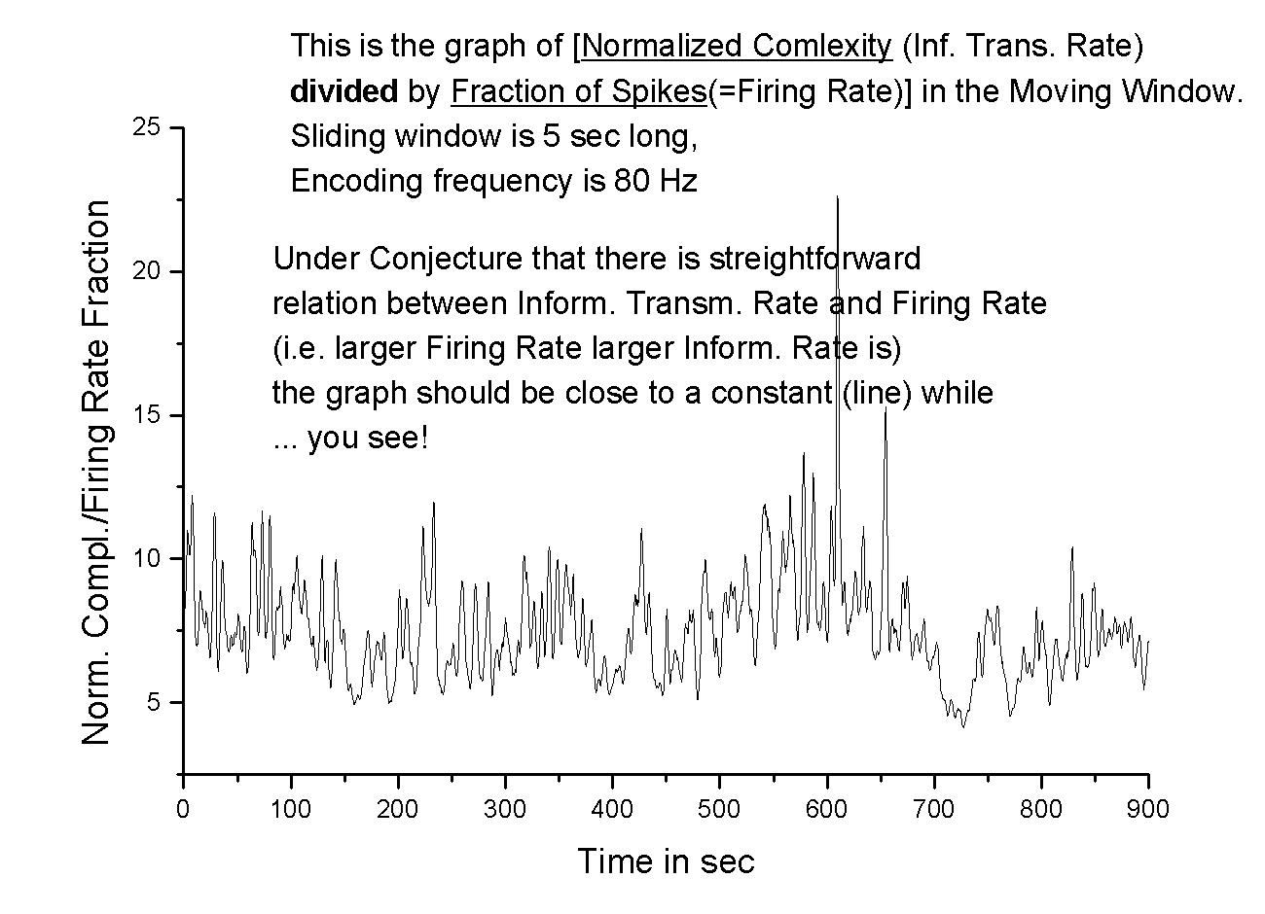
On the graph the following function is depicted:
$$t↦\frac{\text{Normalized} \text{Complexity}(=\text{Entropy} \text{Rate})(t)}{\frac{\text{Number} \text{of} \text{Spikes}(i\text{.}e\text{.} \text{ilosc} \text{1}\text{nek} \text{in} \text{encoded} \text{spike}−\text{train})}{\text{length} \text{of} \text{slid}\text{.}\text{window} (=\text{400} \text{for} \text{en}\text{.}\text{freq}\text{.}\text{80}\text{Hz} i \text{wind}\text{.}\text{length} 5\text{sec})}(t)}$$

