Chaos and Determinism in the Twodimensional Convection

I.B. Palymskiy

Novosibirsk Humanitarian University,
Novosibirsk Military Institute, Novosibirsk, Russia

Palymsky@online.sinor.ru, palymsky@hotmail.com

ABSTRACT

We study by spectral method regimes of convectional currents in a problem Rayleigh - Benard at Rayleighs number from 5 up to 3000 critical values. The different regimes are calculated - stationary, periodic, two-frequency quasiperiodic and stochastic.

INTRODUCTION

The convection flows of viscous incompressible fluid heated from below were calculated by many authors [1-3,8,9] using, as a rule, the spectral method with periodic boundary conditions. The convection flow regimes are well studied for supercriticalities up to
r = Ra/Ra_{cr} ≤ 300, Ra_{cr} = 657.5 [1] and symmetric solutions are studied up to r = 1000 [2]. It is established that as the supercriticality increases at r > 1, a zero solution becomes unstable and the secondary stationary solution arises, followed by the periodic and two-frequency ones. However, replies to the question on the existence of stochastic (chaotic) complex regimes of convection flows are highly contradictory. On the one hand, the summarising paper [1] claims that a “two-dimensional problem on convection contains no solutions differing from the stationary, periodic, and two-frequency ones”. On the other hand, the stochastic regimes of convection flows were determined in a similar problem on the instability of a rotating flat fluid layer heated from below and at small Prandtl number Pr = 0.025 [3]. Finally, the recent paper [9] reports that the region of stochastic regimes holds for supercriticality r ≥ 157 and
Pr = 20.
The question of the existence of stochastic regimes of convection flows is highly important due to its direct relation to the modelling of turbulent flows by direct numerical solution of hydrodynamic equations without using semiempirical relationships. A more thorough study of feasible convection flow regimes is necessary, i.e., from steady-state and periodic to stochastic. A new version of the spectral-difference method is proposed [6] which makes it possible to calculate convection flows for arbitrary Prandtl numbers and supercriticalities of order of r = 1000.
The goal of this paper is to study the feasible convection flow regimes in the Rayleigh-Benard problem.

FORMULATION OF THE PROBLEM

We consider convection flows heated from below in a rectangular region. The fluid is assumed to be viscous and incompressible. The Boussinesq model is used. The horizontal boundaries of the region are considered isothermal and free of shear stresses. The linear temperature profile and soft boundary conditions are set for vorticity ω and stream function φ at vertical boundaries.

The dimensionless input set of equations given in terms of deviations from an equilibrium solution, is of the form [1]:
$\begin{aligned}ω_{t}+\frac{1}{\text{Pr}}(ϕ_{y}ω_{x}−ϕ_{x}ω_{y})=Δ ω+{\text{RaQ}}_{x}, \\ Δ ϕ = −ω , (1) \\ Q_{t}+\frac{1}{\text{Pr}}(ϕ_{y}Q_{x}−ϕ_{x}Q_{y})=\frac{1}{\text{Pr}}Δ Q − \frac{1}{\text{Pr}}ϕ_{x},\end{aligned}$
where φ is a stream function, ω is the vortex, Q is the temperature deviation from equilibrium profile (the total temperature being 1-y+Q), Δf = f_{xx} +f_{yy} is the Laplace operator. Ra=gβН³dQ/χν is the Rayleigh number, Pr=ν/χ is the Prandtl number, g is the gravitational acceleration, β, ν, χ are the coefficients of thermal expansion, kinematic viscosity and thermal conductivity, respectively, H is the layer thickness and dQ is the temperature difference at horizontal boundaries.
System (1) is solved in the region G = {(x, y)│0 ≤ x ≤ L, 0 ≤ y ≤1} with the boundary conditions φ = ω = Q = 0 for y = 0, 1; 0 ≤ x ≤ L (at horizontal boundaries) and φ_{x} = ω_{x}= Q = 0 with x = 0, L; 0 ≤ y ≤ 1 (at vertical boundaries).

METHOD OF NUMERICAL SOLUTION

We briefly describe the spectral-difference numerical algorithm and its testing (for details see [6]). The required values ω, φ and Q are to be sought in the form:
$\begin{aligned}ω(t,x,y)=\sum_{k=0}^{N}{\sum_{m=1}^{M−1}{ω_{\text{km}}}}(t)ρ_{k}\text{cos}(α\text{kx})\text{sin}(π\text{my}), \\ ϕ(t,x,y)=\sum_{k=0}^{N}{\sum_{m=1}^{M−1}{\frac{ω_{\text{km}}(t)}{α^{2}k^{2}+π^{2}m^{2}}}}ρ_{k}\text{cos}(α\text{kx})\text{sin}(π\text{my}), \\ Q(t,x,y)=\sum_{k=1}^{N−1}{\sum_{m=1}^{M−1}{Q_{\text{km}}}}(t)\text{sin}(α\text{kx})\text{sin}(π\text{my}),\end{aligned}$

where α = π/L is the wave number, and ρ_{k} = {0.5 (at k = 0, N) and 1 (at 1≤ k ≤ N-1)}.
Following a general ideology of the splitting method, transition from layer n to layer n+1 over time is performed in two steps.
First, we take into account a linear progress of perturbations neglecting interaction between harmonics.

$ω_{t}=\frac{1}{2}Δ ω+{\text{RaQ}}_{x}, Δ ϕ = −ω , Q_{t}=\frac{1}{2\text{Pr}}Δ Q − \frac{1}{\text{Pr}}ϕ_{x}\text{.} (2)$Step 1.
To effectively solve the equations of nonlinear convection transfer for vorticity ω and temperature Q, half the viscous terms is taken into account in the second step.
${\overset{˙}{ω}}_{\text{km}}=−\frac{S}{2}ω_{\text{km}}+\text{Ra}α{\text{kQ}}_{\text{km}}, {\overset{˙}{Q}}_{\text{km}}=−\frac{S}{2\text{Pr}}Q_{\text{km}}+\frac{ω_{\text{km}}αk}{\text{Pr}S}, S=α^{2}k^{2}+π^{2}m^{2}\text{.} (3)$ Substituting expansions of required values, instead of (2), we get the system of two ordinary differential equations for two unknown amplitudes ω_{km} and Q_{km} at k = 0,1...N
and m = 1, 2...M-1:
The system of ordinary differential equations (3) is solved analytically without any approximations over time. The analytical formulas were derived using the program of analytical calculations Maple V Release 4.
The second step takes into account the nonlinear convection transfer, i.e., the interaction between harmonics.

$ω_{t}+\frac{1}{\text{Pr}}(ϕ_{y}ω_{x}−ϕ_{x}ω_{y})=\frac{1}{2}Δ ω, Q_{t}+\frac{1}{\text{Pr}}(ϕ_{y}Q_{x}−ϕ_{x}Q_{y})=\frac{1}{2\text{Pr}}Δ Q , (4)$Step 2.
Here we use a finite-difference scheme of varying directions applied earlier for calculating turbulent convection flows in a rectangular region heated from one vertical side [7].
The standard programs of fast Fourier transform (FFT) by cosines and sins are used to recalculate the required fields from spectral into physical space and back.
All restrictions on the steps over time and space are connected with the necessary calculation accuracy. The numerical method is of the first order of approximation over time and the second order of approximation over space variables.

TESTING OF THE NUMERICAL METHOD

To verify the numerical method accuracy, we compare the spectral characteristics of the linear differential system with those of the numerical method. The numerical method accuracy can be judged from the closeness of the spectral characteristics of both the numerical method and the differential problem. A similar approach was used in [5,10].
Thus, we examine a linear analogue of system (1). The nonlinear terms are rejected and the following solutions are considered:

ω(t, x, y) = a exp(-λt + iαkx)sin(πmy),
φ(t, x, y) = a exp(-λt + iαkx)sin(πmy)/S,
Q(t, x, y) = b exp(-λt + iαkx)sin(πmy),

As previously, S = α²k² + π²m², a and b are the amplitude constants and increment λ is found from the problem on its eigen values.
Similar considerations are performed for the numerical method. It is proved [6] that if
Pr = 1, then we get

λ_{sp} = λ_{d} + τ²(α⁶k⁶ + π⁶m⁶)/96 - H1²α⁴k⁴/24 - H2²π⁴m⁴/24,

In this case, λ_{sp} and λ_{d} are the increments of an increase of perturbations corresponding to the spectral-difference numerical method and the differential problem, respectively.
Fig. 1 shows the spectral curves corresponding to the first three modes m=1,2,3 as functions of kα, with Ra = 1000 Ra_{cr}, Pr = 2, α.=1, N = 64, M = 16, τ = 4*10⁻⁵. The solid line is the differential problem, the dotted line is the spectral-difference numerical method.
When the Rayleigh numbers are of order of 1000 critical values, the spectral curves, corresponding to the differential problem and the spectral-difference numerical method, are
closely allied. In the region of the wave numbers corresponding to increasing harmonics, the
deviation of increments does not exceed 5%. The spectral characteristics of the differential problem are comparatively well (deviation no more than 5%) reproduced by the numerical method with the Prandtl numbers from 0.01 to 100.
For comparison with the results of paper [1], we calculated the steady convection flow in the rectangular region with periodic boundary conditions by homogeneous coordinate x:

φ(t, x + 2π/α, y) = φ(t, x, y), ω (t, x + 2π/α, y) = ω (t, x, y), Q(t, x + 2π/α, y) = Q(t, x, y).

The results were compared by the Nusselt number and fig. 2 plots the Nusselt number vas supercriticality r at 1 ≤ r ≤ 40 (Pr = 10, α = 2.22) where the solid line denotes calculations in terms of the spectral-difference method and sign • denotes the results of [1] reproduced to within the graphical accuracy.

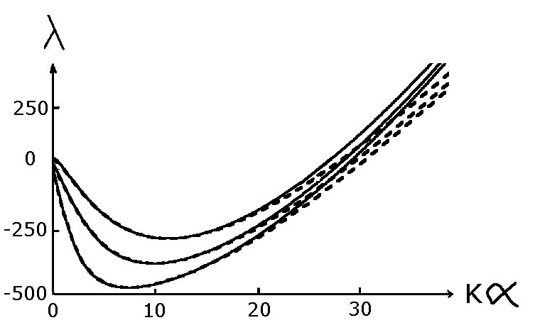
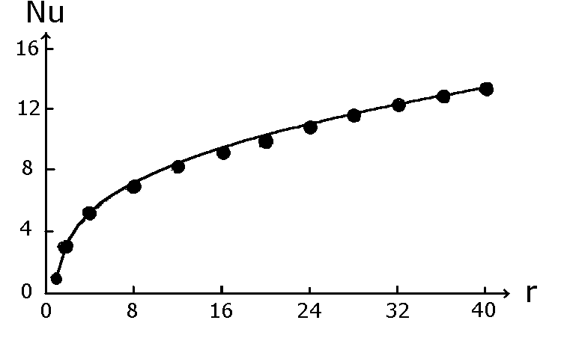 Figure 1 Spectral curves Figure 2 Simile of Nusselt numbers

NUMERICAL STUDY OF CONVECTION FLOW REGIMES

Now we consider results of the numerical studies of convection flow regimes in the Rayleigh-Benard problem. The following values were calculated:
$\text{Nu}0=\frac{α}{π}\int_{0}^{π/α}{Q_{y}}(t,x,0)\text{dx}−1, \text{Nu}0≈\sum_{k=1}^{N−1}{}\sum_{m=1}^{M−1}{(1−(−1)^{k})Q_{\text{km}}\frac{m}{k}−1,}$Nusselt numbers, calculated by the lower
$\text{Nu}1=\frac{α}{π}\int_{0}^{π/α}{Q_{y}}(t,x,1)\text{dx}−1, \text{Nu}1≈\sum_{k=1}^{N−1}{}\sum_{m=1}^{M−1}{(1−(−1)^{k})(−1)^{m}Q_{\text{km}}\frac{m}{k}−1}$and upper
horizontal boundaries;
the integral over the area of the vorticity squared (proportional to enstrophy):

$E=\int_{0}^{1}{}\int_{0}^{L}{ω^{2}}\text{dxdy}≈\frac{L}{4}\sum_{k=0}^{N}{}\sum_{m=1}^{M−1}{ρ_{k}}(ω_{\text{km}})^{2},$
where ρ_{k} = {0.5 at k = 0 and 1 if 1≤ k ≤ N)}. We also calculated the mean-square temperature deviation from the equilibrium distribution Q_{sr} and the mean-square value of the stream function F_{sr,} the mean Nusselt number Nu_{sr} = (Nu0+Nu1)/2 and mean amplitude Q_{12sr} with respect to time.
In each calculation we performed 55000 steps over time. In the region of developed flow, the step over time was constant. Its initial value was τ = 2*10⁻⁴ and in the region of developed flow, the step over time was τ = 4*10⁻⁵. The value under study was determined through 50 steps over time. Therefore, 1100 values were obtained. Then the last 512 values were determined and the Fourier transform was taken using a standard procedure of the mathematical system Mathcad 8. Thereafter the modulus of the complex Fourier coefficient was graphically given as a function of harmonic number. As a rule, the spectral analysis was carried out for the time dependencies of either the Nusselt number Nu0 or amplitudes Q₁₂, Q₁₇, Q₇₁.
Now, let us say some words about the choice of the number of harmonics N and M. To correctly reflect the flow development, it is necessary (for a given α) to take into account all increasing long-wave harmonics and a sufficient number of the decaying short-wave ones. According to a simple analysis of spectral curves λ_{d} (Ra/Ra_{cr} = 1000, Pr = 2), the harmonics decay with k > 29 or m > 6. Therefore, we choose N = 64 (0 ≤ k ≤ 64) and M = 16
(0 ≤ m ≤ 16).
In all numerical calculations, it was assumed that α = 1. The initial conditions were: Q = 0 for the temperature field and one nonzero harmonic amplitude ω_{1,2} = ±1 for vorticity. When calculating stationary solutions, the stationary fields of temperature and vorticity, obtained for other supercriticalities, were set as initial conditions.
With Pr = 2 (corresponding to water at 88˚C), we performed a great number of calculations in which the supercriticality r varied from 5 to 3000.

Steady-State Regimes

For supercriticality up to r = 385 only stationary solutions were derived. With small supercriticalities r ≈ 5, depending on the initial data, there were four different steady-state regimes: two- and three-vortex (fig. 3, stream function at r = 150), four-vortex (fig. 4, stream function at r = 350), and five-vortex (fig. 5, stream function at r = 5).
All calculated steady-state regimes are related to the symmetry of a particular form: the two- and four-vortex regimes are symmetric about the horizontal line y = 0.5 and antisymmetric about the vertical one, x = L/2. The three- and five-vortex regimes are symmetric about the turn by π/2 around the region centre. No systematic calculations of the two-vortex stationary regime were performed at moderate and high supercriticalities for some difficulties in calculations due to the presence of a thermal boundary layer at the lower boundary. The five-vortex regime was successfully extended by continuity up to the supercriticality r ≈ 42, and the four- and three-vortex ones were extended by continuity to
r = 385 and r = 428, respectively.
The Nusselt numbers Nu_{sr} as the functions of supercriticality r are shown in fig. 6 for the three- (dotted line), four- (solid line) and five (•)-vortex flow regimes.

Periodic and Quasiperiodic Regimes

When r = 385, a high-frequency periodic regime smoothly derives from the four-vortex steady-state regime. Figure 7 depicts: • - the amplitude of oscillations in the Nusselt number as a function of supercriticality r (calculated results) and the solid line – 0.0774* (r - 385)^{0.5}.
An increase in the amplitude of oscillations by the root law testifies to a smooth self-excitation of oscillations [4, p.141]. This periodic regime is characterised by a simple time spectrum with the dominating basic frequency and its multifrequencies of a considerably smaller (by two orders of magnitude) amplitude, the antisymmetry about the vertical line x = L/2 and the high oscillation frequency with respect to time. The wavelength corresponding to the basic frequency monotonously decreases from 0.011 (at r = 385) to 0.0063 (at r = 850) of the dimensionless time. In the range 385 ≤ r ≤ 850 the wavelength can be calculated from the equation:
L = 1.024/(92.01+ 0.188*(r - 385) - 8.1*10⁻⁵*(r - 385)²),
derived by processing the calculated data, where L is the wavelength corresponding to a given frequency. Determinacy of a given periodic regime is demonstrated in fig. 8 where sign • denotes the solution at different times in the Q₁₂ , Q₁₇ plane at r = 430.
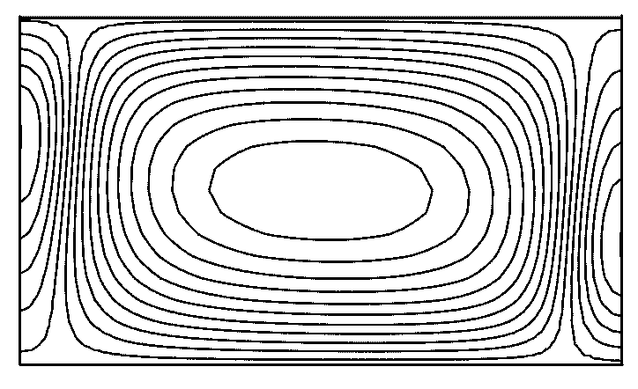
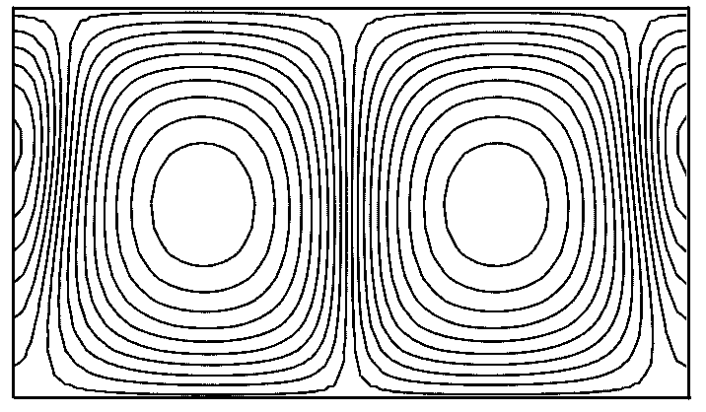
Figure 3 Three-vortex structure Figure 4 Four-vortex structure

Figure 5 Five-vortex structure Figure 6 Nusselt numbers for stationary regimes
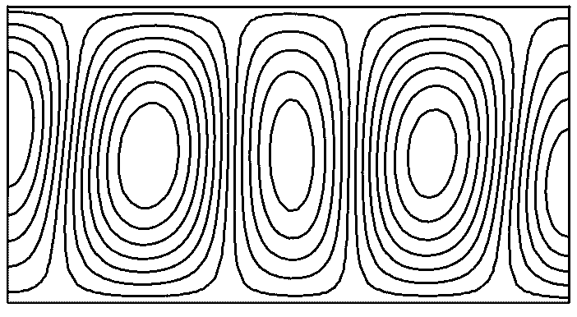
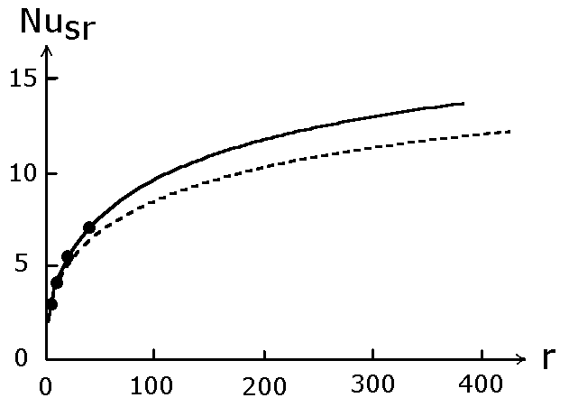
The video film about the progress of stream function with time shows that a given regime is a four-vortex structure similar to that in fig. 4 that realises the high-frequency oscillations with time remaining antisymmetric about x=L/2.
With supercriticality r = 850, the high-frequency periodic regime is rigidly replaced by the low-frequency quasiperiodic one. In this case, the required fields have low-frequency
oscillations with a period of about 0.4 overlapped by the high-frequency ones. Fig. 9 shows the Nusselt number Nu0 as a time function at r = 875.
With r = 875, the signal time spectrum Nu0(t) (fig. 10) shows the quasiperiodicity (two-frequency) and regularity of this regime, because the extremal values (peaks) in the spectrum represent the combinations of basic frequencies f₁ and f₂ as k₁·f₁ ± k₂·f₂, here k₁ and k₂ are whole numbers. On the fig. 10, the harmonic number and the modulus of the complex Fourier coefficient are plotted along the axes.
The video film about the stream function progress with time shows that upon flow evolution, the four-vortex structure exhibiting no symmetry properties, periodically arises (maxima of the Nusselt number) and decays. Note that at 842 ≤ r ≤ 860 there are the high-frequency periodic and low-frequency quasiperiodic regimes. Therefore, it is impossible to accurately determine the boundary position between these regimes.

Stochastic Regime

When r ≈ 890, the quasiperiodic regime rigidly transforms to the stochastic one. Fig. 11 shows the Nusselt number Nu0 as a time function for r = 1000. Examining both the video film about the stream function progress with time and the plot of a change in the Nusselt number, we see that the local maxima in the plot of the Nusselt number are related to the formation and decay of vortex structures. Sign □ denotes the birth of the four-vortex structure and sign x denotes its decay. Sign • shows the initial flow ruin due to the change of harmonic ω_{1,2} (initial data) by harmonic ω_{9,2} more rapidly increasing in linear approximation (t ≈ 0.06) with its subsequent dominating development and destruction by nonlinearly with a loss of flow symmetry (t ≈ 0.1).

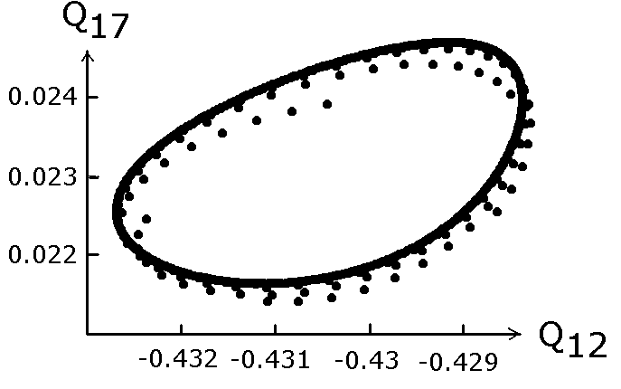
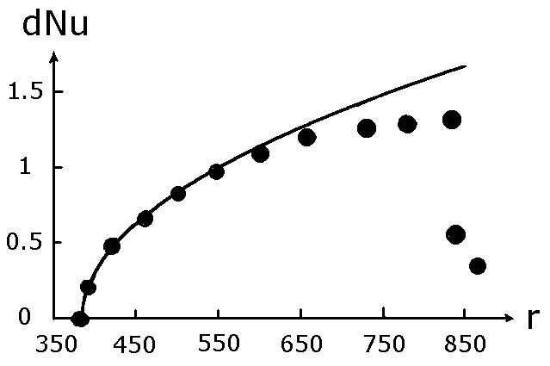

Figure 7 Amplitude Nusselt number oscillations Figure 8 Solution in the Q₁₂, Q₁₇ plane
Figure 9 Nusselt number Figure 10 Time spectrum of Nu0
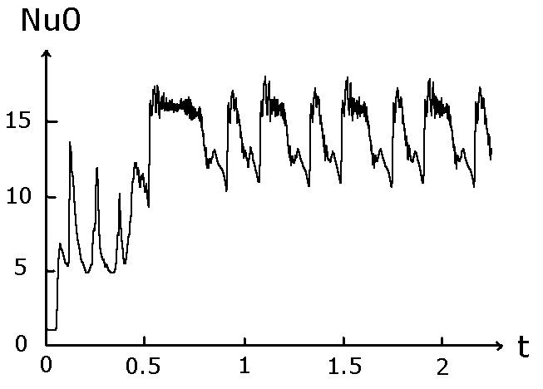
Calculations involving a four-times increase in steps over time (220000) show that the quasiperiodic regime established at 1.64 ≤ t ≤ 2.34 further breaks down and, as a whole, the
oscillations of the Nusselt number with time are of irregular character.
With r = 1000, the fig. 12 shows the continuous time spectrum of the Nusselt number.
Analysing the results of numerical calculations shows that the lifetime of the large-scale four-vortex structure is a random value distributed in terms of a normal law. The mean value of its lifetime (mathematical expectation) is 0.06 and the mean-square deviation of the vortex structure lifetime from its mean value (the square root of dispersion) is 0.02. The ratio between the mean lifetime of the large-scale four-vortex structure and the mean duration of transient processes amounts to 0.26.
The amplitude of harmonic Q₇₁(t) has most rapidly increasing in linear approximation. A key role of nonlinear processes is clear from fig. 13 showing Q₇₁(t) as a time function.
Sign • in fig. 14 denotes the solution in the Q₁₂, Q₁₇ plane at different times for r = 1000 which is typical of the stochastic regime.
Test calculations were also performed for stochastic regimes with different initial data, steps over time τ, the different number of harmonics with respect to x and y. They show that all mean flow characteristics weakly change with variations in initial data, steps over time τ, and an increase in N and M.

CONCLUSIONS

Studying the calculated results for α = 1, Pr = 2, 5 ≤ r ≤ 3000 leads to the following conclusions on the feasible convection flow regimes:
1. With supercriticality up to r = 385, there are only steady-state convection regimes.
2. With r ≈ 385, the high-frequency periodic regime smoothly originates from the four-vortex steady-state regime.
3. With r ≈ 850, a new transient low-frequency quasiperiodic (two-frequency) regime rigidly arises.
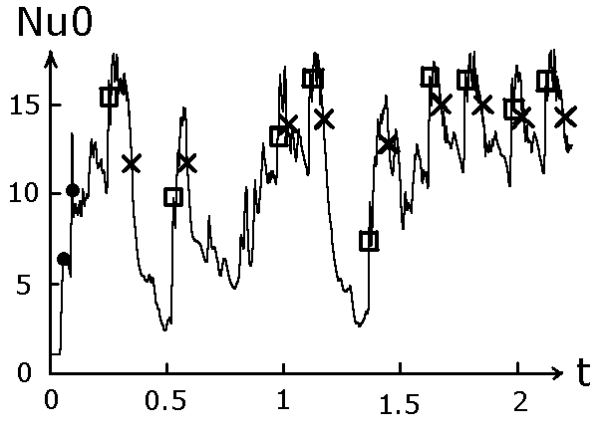
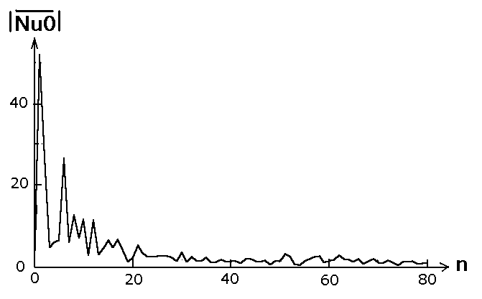
Figure 11 Nusselt number Figure 12 Time spectrum of Nu0

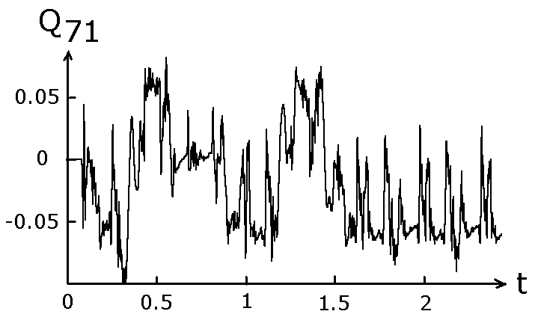
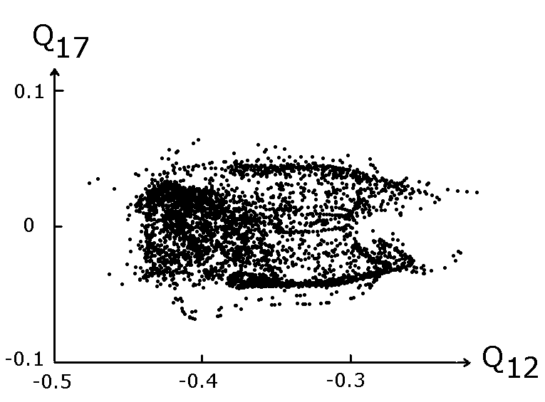
Figure 13 Amplitude of harmonic Q₁₂(t) Figure 14 Solution in the Q₁₂, Q₁₇ plane

4. With r ≈ 890, the low-frequency quasiperiodic regime rigidly transfers into the stochastic one. A study of the stochastic regime structure shows that it is based on the large-scale four-vortex structure that irregularly births (the maxima of the Nusselt number) and decays. The lifetime of this vortex structure is a random variable distributed by the normal law.
5. A successive complication of the convection flow regime with increasing supercriticality is followed by a successive disymmetrization of flow.

REFERENCES

1. K.I. Babenko, A.I. Rakhmanov. A numerical study of two-dimensional convection. Moscow, 1988 (preprint IPM, AN SSSR; N. 118, 26 P., in Russian).
2. J.H. Curry, J.R. Herring, J. Loncaric, S.A. Orszag. Order and disorder in two-and three-dimensional Benard convection // J. Fluid Mech. 1984, V. 147, P. 1-38, in Russian.
3. S.Ya. Gertzenshtein, E.B. Rodychev. On the models of transition to turbulence upon convection instability //Sov. J. Modeling in mechanics (Modelirovanie v mexanike), 1989, V. 3(20), N. 4, P.59-65, in Russian.
4. L.D. Landau, E.B. Livshitz. Theoretical physics, hydrodynamics. Nauka Publisher, Moscow, 1988, 735 P., in Russian.
5. N.V. Nikitin. Spectral-finite-difference methods for calculating turbulent incompressible flows in pipes and channels // Rus. J. of computational mathematics and mathematical physics (Zhurnal vychislitelnoy matematiki i matematicheskoi fiziki), 1994, V. 34, N. 6, P. 909-925, in Russian.
6. I.B. Palymskiy. The method of numerical simulation of convection flows // Rus. J. Computational technologies (Vychislitelnye texnologii), 2000, V.5, N.6, P.53-61, in Russian.
7. V.M. Paskonov, V.I. Polezhaev, L.A. Chudov. Numerical simulation of heat-and-mass exchange processes. Nauka Publisher, Moscow, 1984, 288 P., in Russian.
8. N.V. Petrovskaya. On the application of Galerkin method to the study of transitions in the problem of Rayleigh convection // Sov. J. News of academy of sciences USSR
(Izvestiya AN SSSR), Ser. MZh i G, 1984, N. 2, P. 22-27, in Russian.
9. E.B. Rodichev, O.V. Rodicheva. On two-dimensional turbulence in the Rayleigh-Benard problem // Rus. J. Reports of academy of sciences USSR (Doklady AN SSSR), 1998, V. 359, N. 4, P. 486-489, in Russian.
10. B.L. Rozhdestvensky, M.I. Stoinov. Algorithms for integrating the Navier-Stokes equations having analogies of the laws of conservation of mass, pulse and energy. Moscow, 1987 (preprint IPM AN SSSR; N. 119, 28 P., in Russian).

