Direct Numerical Simulation
of Turbulent Benard Convection

I.B. Palymskiy

Novosibirsk Branch of Modern Humanitarian University,
Novosibirsk, Russia, 630064

Convectional flow in a horizontal layer numerically is simulated at heating from below. The fluid is viscous and incompressible. The flow is non-stationary and two-dimensional. Boundaries of a layer are isothermal and free from shearing stresses. The model Boussinesq is used without semiempirical relations.
The goal of this work is a study of stochastic regime of convectional flows and simile with experimental data and numerical results of other authors for Rayleigh numbers of order of 1000 critical values.
The author has developed the special numerical method [1]. It is grounded on spectral representation of fields of a vorticity and temperature. The idea of fission is used. The complete development of perturbation is taken into account in two stages. At the first stage we take into account linear growth of perturbations, then - nonlinear convective transfer. At the first stage, the system of the ordinary differential equations is solved analytically in spectral space. No approximations on time are applied. At the second stage, an alternating direction method is used for solving the system equations of nonlinear convective transfer in physical space.
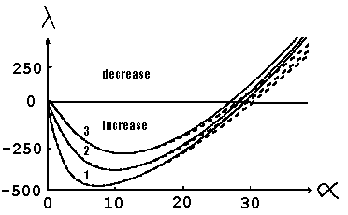
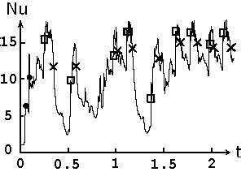
As a rule, we used 65 and 17 harmonics on space variables. To verify the numerical method accuracy, we compare the spectral characteristics of the linear differential system with those of the numerical method. The numerical method accuracy can be judged from the closeness of the spectral characteristics of both the numerical method and the differential problem. Fig. 1 shows the spectral curves corresponding to the first three modes m = 1,2,3 as functions of wave number α, with Rayleigh number Ra = 1000·Racr (Racr = 657.5), Prandtl number Pr = 2 and step on the time τ = 4*10⁻⁵.
Figure 1. Spetral cirves.
At the fig. 1, the solid line represents the differential problem, the dotted line - the spectral numerical method.
When the Rayleigh numbers are of order of 1000 critical values, the spectral curves, corresponding to the differential problem and the spectral numerical method, are closely allied. In the region of the wave numbers corresponding to increasing harmonics, the deviation of increments does not exceed 5%. The spectral characteristics of the differential problem are comparatively well (deviation no more than 5%) reproduced by the numerical method with the Prandtl numbers from 0.01 to 100. It ensures exact reproduction of infinitesimal linear perturbations.
We investigated the stochastic convection regimes for the Prandtl number equal 2 and 10 and Rayleigh numbers of order of 1000 critical values. According to the results of calculations the film was composed. It displays development of the stream function and temperature in time. The study of film and graph of a modification of an integrated Nusselt's number in time has shown that the local maximums on the graph of a Nusselt's number are interlinked with the birth and destruction of vortex structures. The fig. 2 represents Nusselt number as time function (Ra = Racr, Pr = 2), sign □ denotes the birth of the four-vortex structure and sign x denotes its decay. Sign ● shows the initial flow ruin due to the change of harmonic ω₁₂ (initial data) by harmonic ω₉₂ more rapidly increasing in linear approximation (t ≈ 0.06) with its subsequent dominating development and destruction by nonlinearly with a loss of flow symmetry (t ≈ 0.1).

Figure 2. Nusselt number as time function.

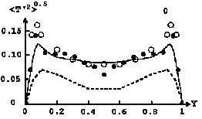
Analysing the results of numerical calculations shows that the lifetime of the large-scale four-vortex structure is a random value distributed in terms of a normal law. The mean value of its lifetime (mathematical expectation) is 0.06 and the mean-square deviation of the vortex structure lifetime from its mean value (the square root of dispersion) is 0.02. The ratio between the mean lifetime of the large-scale four-vortex structure and the mean duration of transient processes amounts to 0.26.
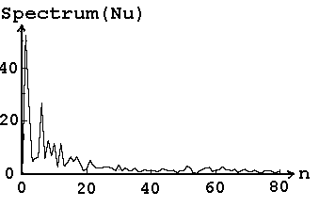
With Ra/Racr = 1000 and Pr = 2, the fig. 3 shows the continuous time spectrum of the Nusselt number.
Figure 3. Time spectrum of the Nusselt number.

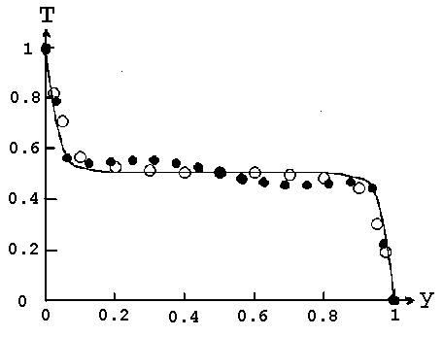
The fig.4 represents the average temperature profile for Ra/racr = 1000 and Pr = 10. At the fig. 4 and 5 below Y denotes transverse coordinate.
Figure 4. Average temperature profile.

Here sign ● denotes the results of present work, sign Ο denotes the results of the numerical simulation [2], solid line - experimental results [3].
The fig.5 represents the root-mean-square temperature deviation from average temperature profile for Ra/racr = 1000 and Pr = 10. Here sign ● denotes the results of present work, sign Ο denotes the results of the numerical simulation [2], solid line - experimental results [4], dash line - experimental results [5].
The fig.6 represents mean Nusselt number as function from r = Ra/Racr, Racr = 657.5. Here sign ● denotes the results of present work, solid line - experimental results [3], dash line - experimental results [6], sign Ο denotes the results of the experimental work Silveston (1958) from work [6].

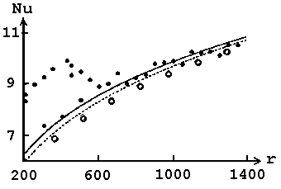
Figure 5. Root-mean-square deviation of temperature.
Figure 6. Mean Nusselt number.

In conclusion, we note that calculating regime of convection and experimental data are closely allied
(fig. 4-6). A temporal spectrum calculated on the graph of a Nusselt's number in time and a mean profile of temperature are typical to stochastic regimes. The lifetime of vortex structure is a random quantity, it is distributed according to the normal law.

References
[1]. I.B. Palymskiy: “Method for numerical modelling of convective flows”, Numerical technologies. 5(6), 53-61, (2000). Novosibirsk, Russia (in Russian).
[2]. G. Grotzbach: “Direct numerical simulation of laminar and turbulent Benard convection”, Journal of Fluid Mechanics, 119, 27-53, (1982).
[3]. T.Y. Chu, R.J. Golgstein: “Turbulent convection in a horizontal layer of water”, Journal of Fluid Mechanics, 60(1), 141-159, (1973).
[4]. J.W. Deardorff, G.E. Willis: Investigation of turbulent thermal convection between horizontal plates”, Journal of Fluid Mechanics, 28, 675-704, (1967).
[5]. D.B.Thomas, A.A. Townsend: “Turbulent convection over a heated horizontal surface”, Journal of Fluid Mechanics, 2, 473-492, (1957).
[6]. H.T. Rossby: “A study of Benard convection with and without rotation”, Journal of Fluid Mechanics, 36,
309-335, (1969).

