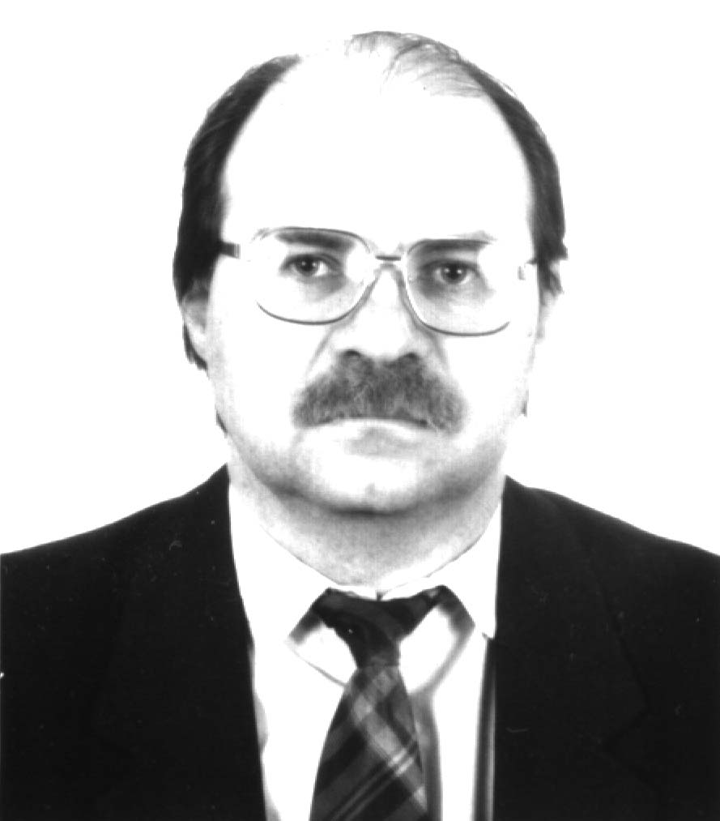
CURRICULUM VITAE

Dr. Igor B. Palymskiy

PERSONAL INFORMATION

First Name: Igor
Family Name: Palymskiy
Date of Birth: Febrary 21, 1958
Nationality: Russian
Office Address: Novosibirsk Military Institute,
Novosibirsk Branch of Modern Humanitarian Institute, Novosibirsk, 630117, Russia
Home Address: Lesosechnaya st., 4 - 73, Novosibirsk, 630060, Russia
Marital Status: Married, two children
Home phone: +7-3832-33-47-91
E-mail: palymsky@online.sinor.ru, palymsky@hotmail.com

LANGUAGES
English, German, native Russian.

EDUCATION
1965-1975 Secondary Ten-Year School, Magadan, USSR.

1975-1980 Novosibirsk State University, Department of Applied Mathematic,
Diploma: Mechanic and Applied Mathematic,
Specialization: Numerical methods of fluid dynamic,
Diploma Title: Numerical modelling of fluid dynamic problems.

1989 Defense of the Ph.D. in Mathematics and Physics, 13.12.89,
Specialty: Calculus mathematics. Scientific Council of the Institute of Calculus Centre, Siberian Branch of the Russian Academy of Sciences, Novosibirsk, USSR,
Ph.D Title: Split method by physical processes for calculation viscoelastic flows.

1998 Faculty of rise professional qualification, Novosibirsk State University,
Specialization: Informatic,
Diploma Title: Modern informational technologies.

RESEARCH INTERESTS

- Thermal convection in plane layers, direct numerical modelling stochastic and turbulent flows without semi-empirical relations.
- Direct numerical modelling rotation flows (stochastic and turbulent) without semi-empirical relations.
- Numerical methods for solution of partial differential equations describing the hydrodynamic flows, spectral and difference approximations.
- Theoretical fluid dynamics - initial Hopf bifurcations, periodic and quasiperiodic flows, birth and death of vortex structures, transient into the turbulence.
- Convectional flows with strongly dependence thermal expansion coefficient
from temperature, for instance, the convection in chemically equilibrium reacting flows.
- Convection in melting metal.
- Convection in Earth mantle, atmosphere and ocean.
- Numerical investigation hydrodynamical flows, also viscoelastic.

COURSES TAUGHT

- Theoretical mechanic, Novosibirsk Building Academy, Novosibirsk Military Institute, 1991-2002.
- Basic course of the information technologies, Novosibirsk Branch of Modern Humanitarian University, 1999-2002.
- Modern information technologies, Novosibirsk Branch of Modern Humanitarian University, 1999-2002.
- Technical hydrodynamics and hydraulics, Novosibirsk Military Institute, 1997-1999.
- Basic course of the high mathematic, Novosibirsk Branch of Modern Humanitarian University, 1999-2002.
- Machine and mechanism theory, Novosibirsk Military Institute, 1997-1999.

PEDAGOGICAL ACTIVITIES

01/1991 - 03/1996
Associate professor of Novosibirsk Building Academy, Department of theoretical mechanic. Lectures: theoretical mechanic.
03/1996 - present
Associate professor of Novosibirsk Military Institute, Department of theoretical mechanic. Lectures: theoretical mechanic, technical hydrodynamics and hydraulics, machine and mechanism theory.
04/1999 - present
Associate professor (0.5 staff member) of the Modern Humanitarian University. The Branch of the University in Novosibirsk. Lectures: high mathematics, logic, informatics, modern information technologies.

RESEARCH ACTIVITIES

09/1980 - 09/1984
Junior researcher, researcher of Thermophysics Institute, Siberian Branch of the Russian Academy of Sciences, Novosibirsk, Russia, in the laboratory of hydrodynamical wakes.

09/1984 – 12/1990
Postgraduate, researcher, senior researcher of Applied and Theoretical Mechanics Institute, Siberian Branch of the Russian Academy of Sciences, Novosibirsk, Russia, in laboratory of mathematical modelling of hydrodynamical flows.

COMPUTER CODES

Tex, Latex, Mathcad, Maple, Fortran PS.
The Programm Maple is use for analytical calculations.
I was having generated the programm for the calculating incompressible, two-dimensional, unstationary flows, also for calculating viscoelastic flows. This programm use the finite difference method.
In present time, I have a code (programm at Fortran) for the numerical modelling of the unstationary two-dimensional flows (stochastic) in the layer heated from below with stress-free boundary conditions, this programm use the spectral method and analytical formulas. I hope to generate a code for the numerical modelling of the unstationary three-dimensional flows (turbulent) in the layer heated from below with stress-free boundary conditions and to hold investigations in this problem.

RESEARCH EXPERIENCE AND THE MAIN SCIENTIFIC RESULTS

Numerical solving the equations of hydrodynamics (finite difference)

- Palymskiy I.B.
About boundary conditions and calculation of pressure at the solution of the Navier-Stokes equations by a method of split on physical processes.
1986, 24 p. (Preprint Applied and Theoretical mechanics Institute, Siberian Branch of the Russian Academy of Sciences, N 1-86), Novosibirsk, Russia (in Russian).
- Palymskiy I.B.
About boundary conditions and calculation of pressure at a numerical modeling of incompressible streams.
Modelling in mechanics, 1987, Vol.1 (18), N 5, pp. 91-103, Novosibirsk, Russia (in Russian).
- Palymskiy I.B.
About boundary conditions at the solution of the equations of the Navier-Stokes by a method of split on physical processes.
Conference on a mechanics of reacting mediums, 1988, pp. 170-172, Krasnoyarsk, Russia (in Russian).

Numerical solving the equations of viscoelastic hydrodynamics (finite difference)

- Palymskiy I.B.
Method of split on physical processes for calculation of viscoelastic flows.
Modelling in mechanics, 1988, Vol. 2 (19), N 2, pp. 119-132, Novosibirsk, Russia (in Russian).
- Palymskiy I.B.
Numerical modeling of convectional currents at high Weissenberg numbers.
1988, 48 p. (Preprint Applied and Theoretical mechanics Institute, Siberian Branch of the Russian Academy of Sciences, N 15-88), Novosibirsk, Russia (in Russian).
- Palymskiy I.B.
About change type of the equations of a viscoelastic fluid.
Mechanics of reacting mediums and its appendices, 1989, pp. 256-262, Novosibirsk, Russia (in Russian).
- Palymskiy I.B.
Method of split on physical processes for calculation of viscoelastic flows.
The autoabstract of a Ph. D. Dissertation, 1989, 16 p., Novosibirsk, Russia (in Russian).
- Palymskiy I.B.
Method of split on physical processes for calculation of viscoelastic flows.
Ph. D. Dissertation, 1989, 157 p., Novosibirsk, Russia (in Russian).
The linear and nonlinear analysis of the numerical methods for the nonlinear equations
- Palymskiy I.B.
Qualitative analysis of finite difference numerical methods for the model nonlinear equation with alternating viscosity.
Differential equations, Science and technique, 1992, Vol. 28, N 12, pp. 2148-2158, Minsk, Russia (in Russian).
- Palymskiy I.B.
The linear and nonlinear analysis of the numerical method for calculation of convectional currents.
2002, Novosibirsk, Russia (in print, in Russian).
- Palymskiy I.B.
Numerical modeling of convectional currents at high Weissenberg numbers.
1988, 48 p. (Preprint Applied and Theoretical mechanics Institute, Siberian Branch of the Russian Academy of Sciences, N 15-88), Novosibirsk, Russia (in Russian).
Numerical modelling convectional currents
Method (spectral)

- Palymskiy I.B.
Method for numerical modelling of convective flows. Numerical technologies. 2000, Vol. 5, N 6, pp. 53-61, Novosibirsk, Russia (in Russian).
Chaos and determinism, bifurcations and stability of the stationary solutions, regimes of the convectional currents (results of the numerical investigations by spectral method)

- Palymskiy I.B.
Stability and bifurcations of convection.
Numerical technologies. Special issue [Proceedings of RDAMM], 2001, Vol. 6, part II, pp. 480-484. Novosibirsk, Russia (in Russian).

- Palymskiy I.B.
Regimes of the convectional currents in a Rayleigh-Benard problem.
2002, Novosibirsk, Russia (in print, in Russian).
- Palymskiy I.B.
Chaos and determinism in a two-dimensional convection.
2002, Novosibirsk, Russia (in print, in Russian).
Chaos and determinism in the convection of chemically equilibrium reacting gas

- Palymskiy I.B.
The Rayleigh-Benard convection in a chemically equilibrium gas.
2002, Novosibirsk, Russia (in print, in Russian).
My participation in international conferences

- Palymskiy I.B.
Direct numerical modelling of the transition convectional currents.
Fourth Siberian Congress on Applied and Industrial Mathematician (INPRIM-2000), 2000, part II, pp. 57, Novosibirsk, Russia (in Russian).
- Palymskiy I.B.
Numerical simulation of transitional convective flows.
Lavrentyev Readings, September 18 – 22, 2000, pp. 100, Novosibirsk, Russia (in Russian).
- Palymskiy I.B.
Stability and bifurcations of convection.
Numerical technologies. Special issue [Proceedings of RDAMM], 2001, Vol. 6, part II, pp. 480-484, Novosibirsk, Russia (in Russian).
- Palymskiy I.B.
Determinism and chaos in a twodimensional convection.
The Eighth Congress on Theoretical and Applied Mechanics, August 23-29, 2001, Perm, pp. 474.
Pedagogical and methodical works
- Palymskiy I.B.
Structure of the educational information.
International Scientific - Practical Conference “ Formation adult for a development of the personality and world community “, 1999, pp. 70, Novosibirsk, Russia (in Russian).
- Palymskiy I.B., Aizin L.B.
System of converging forces.
For the students of all specialities Novosibirsk Building Academy, 1992, 20 p., Novosibirsk, Russia (in Russian).
- Palymskiy I.B.
Definition of a centre of gravity of a flat figure.
For the students of all specialities Novosibirsk Building Academy, 1993, 9 p., Novosibirsk, Russia (in Russian).
- Palymskiy I.B.
Course of the lectures on a theoretical mechanics, kinematics and dynamics.
Novosibirsk Military Institute, 2000, 200 pp.
- Palymskiy I.B., Corobcov V.V.
Calculation of a composite construction.
Novosibirsk Military Institute, 2000, 20 pp.

