Emulsions with Nanoparticles for New Materials
(EMMA)

Contract GZ 45.534/1-VI/6a/2003 of the CONEX Project

Midterm Scientific and Management Report

Presented by

O. Univ.-Prof. Dr. Günter Brenn
Project Coordinator

Partners:
- Institute of Fluid Dynamics and Heat Transfer (IFDHT), Graz University of Technology, Graz, Austria (O. Univ.-Prof. Dr. Günter Brenn)
- Laboratory of Chemical Physics and Engineering (LCPE), Faculty of Chemistry, University of Sofia, Sofia, Bulgaria (Prof. Dr. Peter A. Kralchevsky)
- Department of Mechanics and Physics of Fluids (DMPF), Warsaw, Polish Academy of Sciences (Prof. Dr. Tomasz A. Kowalewski)

Contents
1. Objectives | 2
2. Activities and Results Achieved | 2
2.1. Numerical simulation of the flow situation in an experimental device for emulsification | 3
2.2. Detachment of oil drops from solid surfaces in surfactant solutions: Molecular mechanisms at a moving contact line | 5
2.3. Interactions between particles with an undulated contact line at a fluid interface: Capillary multipoles of arbitrary order | 6
2.4. Kinetics of drop breakup during emulsification in turbulent flow | 8
2.5. Optical observations of drop deformation and break-up during emulsification | 9
2.6. Effect of emulsification conditions on mean drop-size | 10
2.7. Conditions for creating thin liquid layers at the contact surface of two other liquids | 11
2.8. High-frequency linear viscosity of emulsions composed of two viscoelastic fluids | 13
2.9. Production of emulsions in shear flow, experimental study | 15
3. Publications and Papers | 17
4. Project Management | 17
5. Conclusion | 21

1. Objectives
The main purpose of the joint work in this project is to explore several new and promising directions for fabrication of nano-composites (colloidosomes, microcapsules, core-shell and other composite particles), as well as nano-structured surfaces and porous layers by using emulsion droplets as precursors and/or templates. The procedures involve the formation of emulsions stabilized by solid particles. Therefore, a large fraction of our efforts are directed to reveal the main factors governing the process of emulsification and the emulsion stability in the presence of solid particles. For our experiments, we selected two emulsification methods, viz. the narrow-gap homogenizer and the membrane emulsification methods. Our first goal is to produce experimental data and theoretical model, and to compare them with respect to the size distribution of the produced drops. The next step is to involve the nanoparticles, whose adsorption at the surfaces of the emulsion drops would lead to the formation of particle-stabilized Pickering emulsions. To understand the underlying processes and mechanisms, we are carrying out both emulsification experiments and model experiments with single drops and liquid films, which would allow direct optical observation and quantitative analysis of the processes (such as kinetics of particle adsorption, film stability and drop-drop coalescence, etc.). In parallel, theoretical models directed to explain the observed dependencies and to reveal the main factors that control the emulsification process are developed and tested against the emulsification and model experiments. The results obtained during the first project year are summarized below, in accordance with our research plan.

2. Activities and Results Achieved
We present the activities undertaken and the results achieved, following the separate tasks formulated in our proposal. In the text, we cite the respective publications and papers that resulted from our work, using the same numbering as in the list of publications. The contributions of the four groups are denoted with the name of the city: Graz, Sofia and Warsaw. Our results during the first project year are summarized in Table 1.

Table 1. Results obtained during the First Project Year
№ | Partner Groups | Research Problem | Annex to the Report | Result: Title of the Annex
1. | Graz | Theoretical interpretation – turbulent flow in narrow-gap homogenizer | Annex 1 | Numerical simulation of the flow situation in an experimental device for emulsification
2. | Sofia & Graz | Theoretical and experimental analysis – membrane emulsification | Annex 2 | Detachment of oil drops from solid surfaces in surfactant solutions: Molecular mechanisms at a moving contact line (paper)
3. | Sofia & Graz | Fabrication of core-shell particles and colloidosomes | Annex 3 | Interactions between particles with an undulated contact line at a fluid interface: Capillary multipoles of arbitrary order (paper)
4. | Sofia | Emulsification experiments – narrow-gap homogenizer | Annex 4 | Kinetics of drop breakup during emulsification in turbulent flow
5. | Sofia & Warsaw | Emulsification experiments – narrow-gap homogenizer | Annex 5 | Optical observations of drop deformation and break-up during emulsification
6. | Sofia | Emulsification experiments – narrow-gap homogenizer | Annex 6 | Effect of emulsification conditions on mean drop-size
7. | Warsaw | Emulsification by liquid jet break-up: drop size distribution | Annex 7 | Conditions for creating thin liquid layers at the contact surface of two other liquids (paper)
8. | Warsaw | Emulsification by liquid jet break-up: drop size distribution | Annex 8 | High-frequency linear viscosity of emulsions composed of two viscoelastic fluids (paper)
9. | Warsaw | Drop-drop interaction in turbulent flow: direct observation of drop break-up and coalescence by a high-speed camera | Annex 9 | Production of emulsions in shear flow, experimental study
Below, we briefly describe the obtained results following the order of the results given in Table 1. Details can be found in the Annexes, which represent an integral part of this report (see Table 1).

2.1. Numerical simulation of the flow situation in an experimental device for emulsification
Research Problem: Theoretical interpretation: turbulent flow in narrow-gap homogenizer
Partner group: Graz
Abstract: The flow configuration was computed for the geometry of the narrow-gap homogenizer. The parameters for the numerical simulation have been determined. The three-dimensional numerical calculations were done with Fluent 6.1.22. The application of two alternative turbulence models did not produce significantly different solutions, as shown by the numerical results. The latter have been used to estimate the maximum drop size. The main assumption is that dynamic pressure forces due to rapid turbulent fluctuations in the vicinity of the drops, which overcome the interfacial tension forces, cause the drop fragmentation. This means that a) only velocity fluctuations over a distance close to the drop diameter are capable of causing large deformations and b) the turbulent eddies causing the deformation lie within the inertial sub-range of the turbulent kinetic energy spectrum. Some part of the turbulence produced in this first wake zone is convected downstream into the second gap, and, hence, in comparison to the first gap, more than double maximum turbulence intensity (T ≈ 20%) is achieved there (Figure 1).
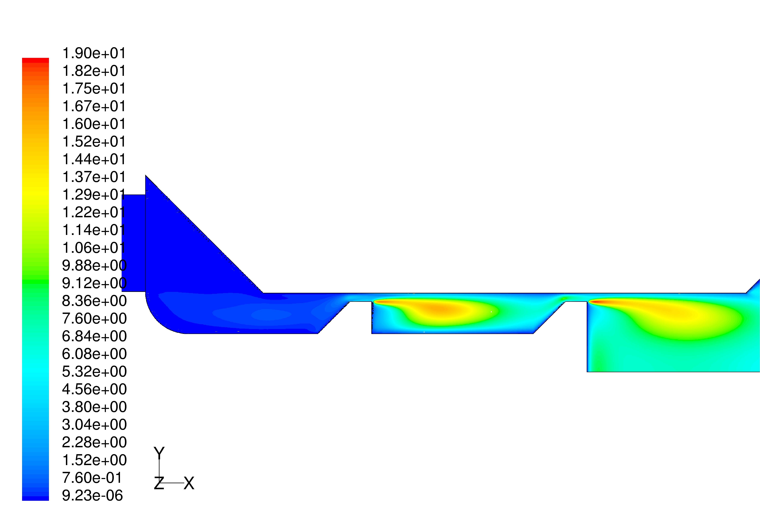
Figure 1. Contours of the calculated turbulent kinetic energy k (m²/s²).
The present simulation makes particularly evident that the turbulent kinetic energy as well as the turbulent dissipation rate are considerably increased from gap to gap. It can be expected that up to some limit a higher number of gaps followed by wakes will basically produce a strongly enhanced average turbulence and dissipation in the gap farthest downstream. Since the magnitude of the dissipation is essential for the droplet break-up mechanism according to the emulsification theory, the observed gap-to-gap increase of the achievable mean dissipation rate has to be considered in the determination of the optimum number of gaps of the processing element.
The estimation of the maximum drop size using the average dissipation rate evaluated with the numerical results in the second gap gave a surprisingly good agreement with experimental data for the simplest droplet-break-up model. Applying on the other hand a basically more advanced model, which also accounts for the viscous forces within the dispersed phase produced considerable over-predictions. The agreement/disagreement of the estimates should not be misinterpreted in terms of the predictive capability of the applied models.
It is finally noted that the drawn conclusions are basically made just for the present case with the two-gap-emulsifier. The sensitivity of the achievable dissipation rates to the gap width as well as to the number of gaps has certainly to be investigated in further simulations, varying the number of gaps as well as the gap width. These simulations will be carried out for the new designed planar emulsifier, where a series of computationally less costly two-dimensional computations might be possible. See Annex 1 for details.

2.2. Detachment of oil drops from solid surfaces in surfactant solutions: Molecular mechanisms at a moving contact line
(Paper in press in Industrial & Engineering Chemistry Research)
Research Problem: Theoretical and experimental analysis: membrane emulsification
Partner groups: Sofia & Graz
Abstract: The process of membrane emulsification is accompanied by formation of oil drops in aqueous phase at the surface of a solid (usually, glass) membrane. During such a process, the motion of the contact line solid-water-oil plays an important role: determines the size of the formed drops. The motion of contact line represents also interest for many other processes of practical importance, such as coating, printing, painting, and detergency. Here, we present experimental data and theoretical model for the dynamics of detachment of hexadecane drops from a solid substrate (glass plate) in aqueous solutions of anionic surfactant and salt, at various temperatures. The influence of the experimental conditions on the motion of the three-phase contact line is investigated. We found indications that water molecules can propagate by lateral diffusion in a thin layer on the surface of the solid plate (see Fig. 2). The driving force of the detachment process, viz. the imbalance of the interfacial tensions at the contact line, is engendered by the water penetration, while the line friction force compensates this imbalance and determines the stationary speed. Excellent agreement between theory and experiment is achieved. The present study specifies the parameters that can be used to quantitatively characterize the rate of drop detachment, determines the values of these parameters at various experimental conditions, and indicates tools for control of the investigated spontaneous process. See Annex 2 for details.
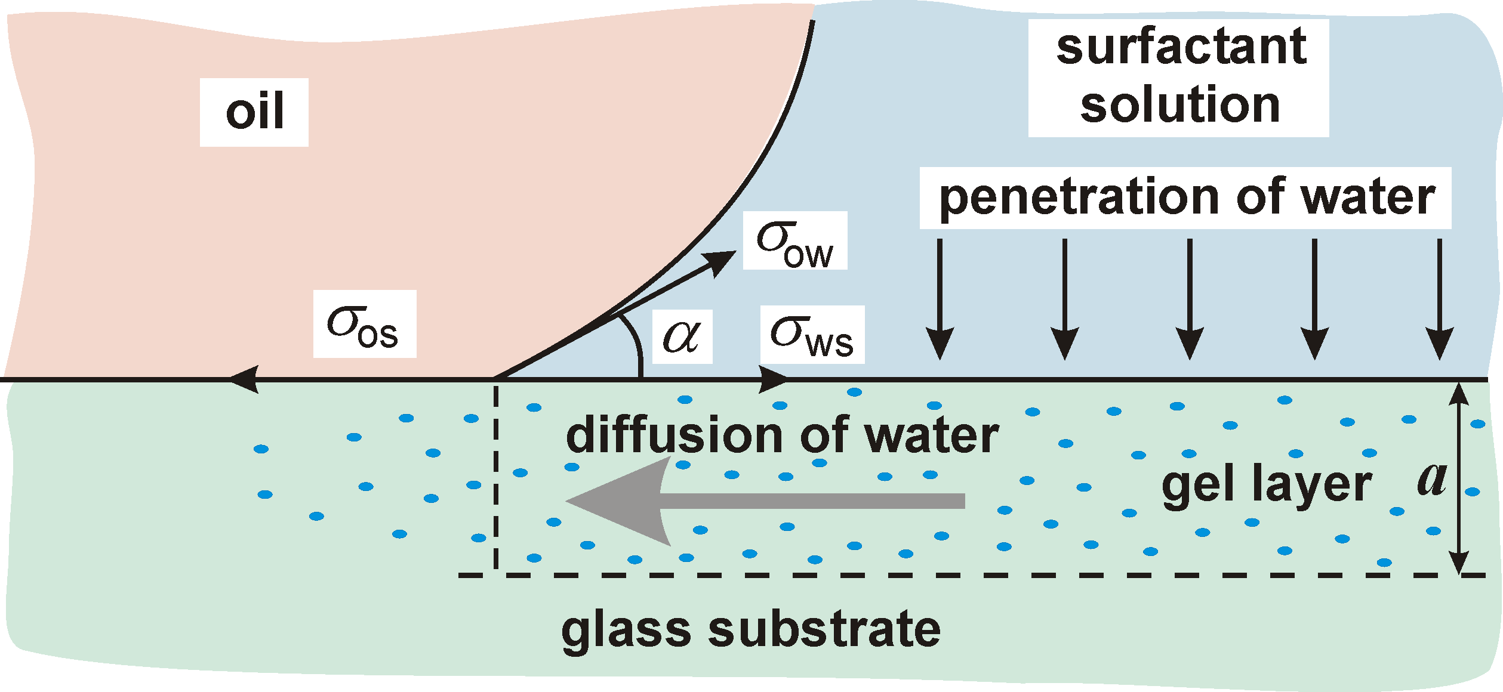

Figure 2. A possible model of the spontaneous detachment of an oil drop from a glass substrate in surfactant solution. Water molecules from the gel layer at the glass-water interface penetrate by diffusion the glass-oil interface (in the close vicinity of the contact line) and alter the local values of the two superficial tensions, σ_{ws} and σ_{os}, which, in their turn, affect the force balance at the contact line.

For details – see Annex 2. The paper was submitted for publication in the journal: Industrial and Engineering Chemistry Research.

2.3. Interactions between particles with an undulated contact line at a fluid interface: Capillary multipoles of arbitrary order
(Paper submitted to Journal of Colloid and Interface Science)
Research Problem: Fabrication of core-shell particles and colloidosomes
Partner groups: Sofia & Graz
Abstract: The lateral capillary interactions are recognized as the driving force of self-assembly of colloidal particles at fluid interfaces, and formation of two-dimensional (2D) colloid crystals. Usually, such forces are operative when the particles are confined in a liquid film. As our goal is to achieve particle ordering at the surface of an emulsion drop (single interface, no liquid film), we have to employ such type of capillary force, which appears at a single fluid phase boundary. Force of this type appears between “capillary multipoles”, which are examined theoretically in the present study.
Figure 3. Lateral capillary forces between floating particles: the interaction is due to the overlap of interfacial deformations created by the separate particles. An undulated contact line at the particle surface could engender the interfacial deformations. In this case, the forces between the particles can be described as interactions between "capillary multipoles", in analogy with electrostatics.
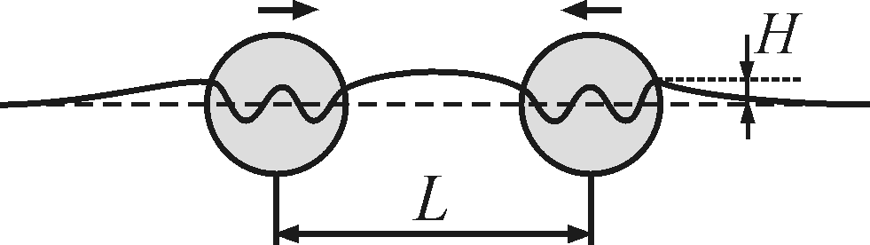

A colloidal particle adsorbed at a fluid interface could have an undulated, or irregular contact line in the presence of surface roughness and/or chemical inhomogeneity. The contact-line undulations produce distortions in the surrounding liquid interface, whose overlap engenders capillary interaction between the particles (Fig. 3). The convex and concave local deviations of the meniscus shape from planarity can be formally treated as positive and negative “capillary charges”, which form “capillary multipoles”. Here, we derive theoretical expressions for the interaction between two capillary multipoles of arbitrary order. Depending on the angle of mutual orientation, the interaction energy could exhibit a minimum, or it could represent a monotonic attraction. For undulation amplitudes larger than 5 nm, the interaction energy is typically much greater than the thermal energy kT. As a consequence, a monolayer from capillary multipoles exhibits considerable shear elasticity, and such monolayer is expected to behave as 2D elastic solid. These theoretical results could be helpful for the understanding of phenomena related to aggregation and ordering of particles adsorbed at a fluid interface, and for the interpretation of rheological properties of particulate monolayers. Related research fields are the particle-stabilized (Pickering) emulsions and the two-dimensional self-assembly of microscopic particles (Fig. 4). See Annex 3 for details.

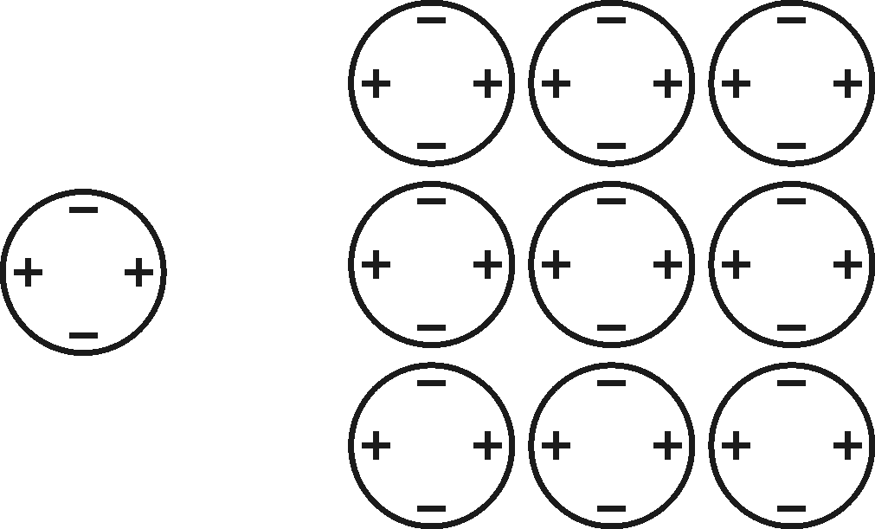
(a)
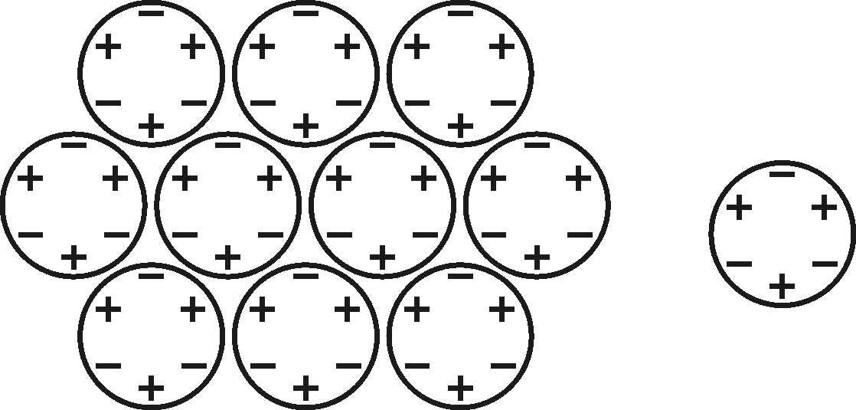
(b)

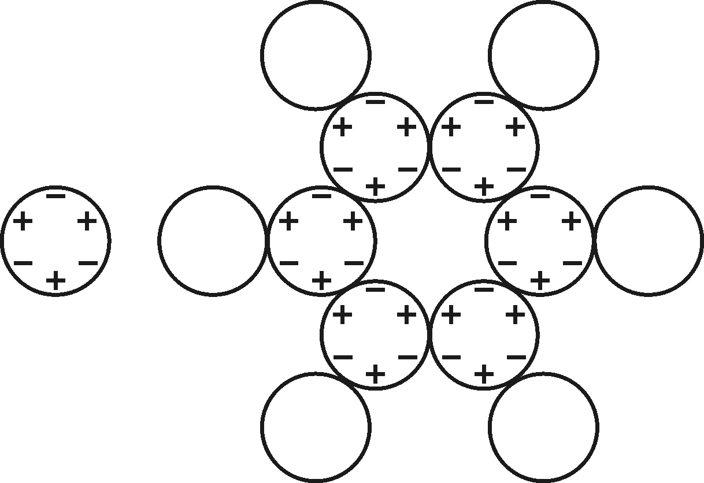
(c)

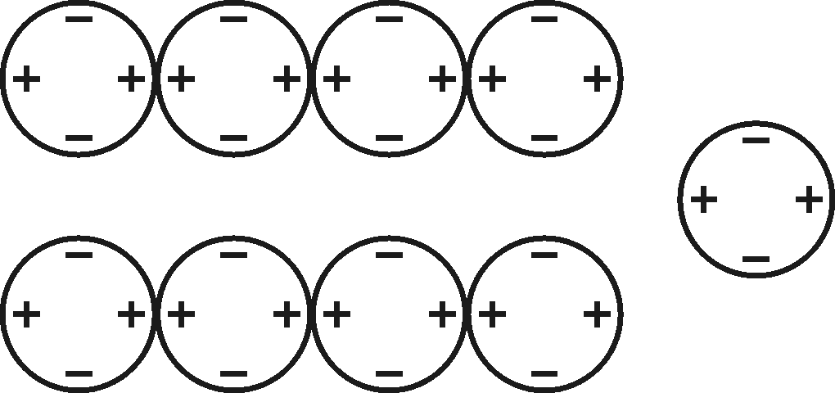
(d)

Figure 4. Two-dimensional arrays formed by capillary quadrupoles (m = 2) and hexapoles (m = 3); the signs “+” and “−” denote, respectively, positive and negative “capillary charges”, i.e. convex and concave local deviations of the meniscus shape from planarity at the contact line. (a) Quadrupoles form tetragonal close-packed array. Hexapoles could form (b) close-packed array; (c) hexagonal array with voids. (d) Linear aggregates made of quadrupoles. In contrast with the electric charges, two similar capillary charges attract each other, while the interaction between opposite capillary charges is repulsive.

2.4. Kinetics of drop breakup during emulsification in turbulent flow
Research Problem: Emulsification experiments – narrow-gap homogenizer
Partner group: Sofia
Systematic set of emulsification experiments is performed to elucidate the role of several factors, which control the process of oil drop breakage during emulsification in turbulent flow. The experiments are performed at high surfactant concentration and low oil volume fraction to eliminate the contribution of drop-drop coalescence. As starting oil-water premixes we use emulsions containing monodisperse oil drops, which are generated by the method of membrane emulsification. By passing these premixes through a narrow-gap homogenizer, working in turbulent regime, we study the evolution of the number concentration of drops with given diameter, as a function of emulsification time. The experimental data are analyzed by using an original kinetic scheme, which takes into account the generation of drops of a given size (as a result of breakup of larger drops) and their disappearance (as a result of their own breakup process). The performed analysis allowed us to determine the rate constant of the process of drop breakup, as a function of drop diameter, hydrodynamic conditions during emulsification, and viscosity of the drop phase. The breakup rate constants, determined in this way, are compared with available theoretical expressions in the literature and their modifications. The comparison shows that the breakup rate constant can be considered as a product of: (a) frequency of collisions between drops and turbulent eddies, and (b) efficiency of drop breakup, which is related to the energy required for drop deformation and subdivision into smaller drops. The energy for drop deformation contains two contributions, originating from the drop surface extension and from the viscous dissipation inside the drop, respectively.

k_{S}
k_{S}
(A)
(B)

Figure 5. Schematic presentation of the processes of drop breakage.
2.5. Optical observations of drop deformation and break-up during emulsification
Research Problem: Emulsification experiments – narrow-gap homogenizer
Partner groups: Sofia & Warsaw
This part of the report describes optical observations, by a high-speed video camera, of oil drops carried by a turbulent flow. These observations provide information for the drop shape, for the modes of drop disruption and for the drop-drop coalescence (e.g., for the contact time between two drops, formation of films between two drops upon collision, etc.).
To perform such observations we first constructed a new version of the narrow-gap homogenizer, with plane geometry, which allows microscope observations of the drops in turbulent flow. Test experiments were conducted to compare the drop size distribution for emulsions prepared with the new homogenizer having plane geometry and the original homogenizer having cylindrical geometry. These tests showed that the drop-size distribution in emulsions obtained by the two homogenizers are similar, which means that the results from the optical observations with the planar homogenizer can be used to interpret data obtained with the cylindrical homogenizer.
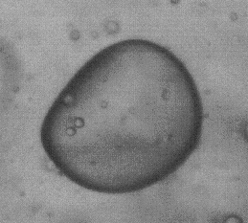
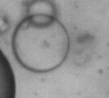
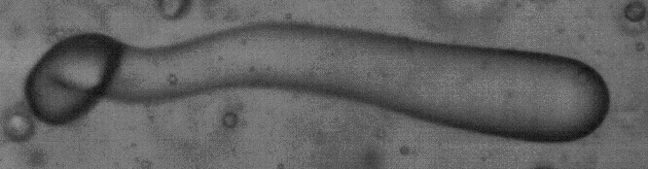
(A)
(B)
(C)

Figure 6. Different drop shapes observed in the space just after the processing element; (A) Bulgy type; (B) Lenticular type and (C) Cigar-type.

Next, preliminary experiments were performed during the visit of Dr. Tcholakova in Warsaw, in collaboration with our Polish partners, to find appropriate experimental conditions for the optical observations. These preliminary experiments provided information about the drop shape in turbulent flow, as well as about the process of drop breakage. Further, more systematic experiments are planned to study the processes of drop breakage and drop-drop coalescence.

2.6. Effect of emulsification conditions on mean drop-size
Research Problem: Emulsification experiments – narrow-gap homogenizer
Partner group: Sofia
In this part of the Report we describe experimental results obtained with narrow-gap homogenizer of cylindrical geometry. The effects of: (1) Construction of the processing element; (2) Viscosity of the aqueous phase; and (3) Viscosity of the oil phase on the mean drop size are studied. All experiments are performed in excess of emulsifier and the effect of drop-drop coalescence is negligible during the emulsification.
The role of the construction of the processing element was studied by comparing three different constructions. We found that the construction of the processing element affects slightly the flow rate of the emulsion through the homogenizer, at fixed driving pressure and gap width, which indicates that the construction of the element does not affect tremendously the hydrodynamic conditions. Furthermore, we found that the mean drop size of the emulsions made with different elements agrees with the prediction of Kolmogorov-Hinze equation, under the assumption that the volume, in which the energy dissipation takes place, is approximately the same for all studied elements.

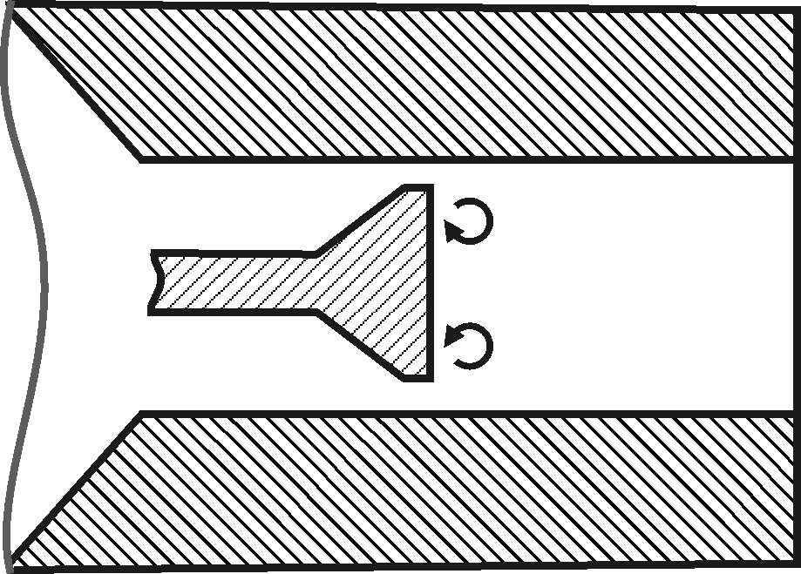
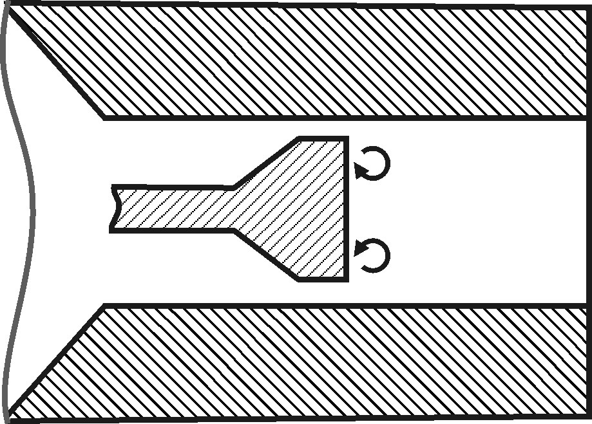
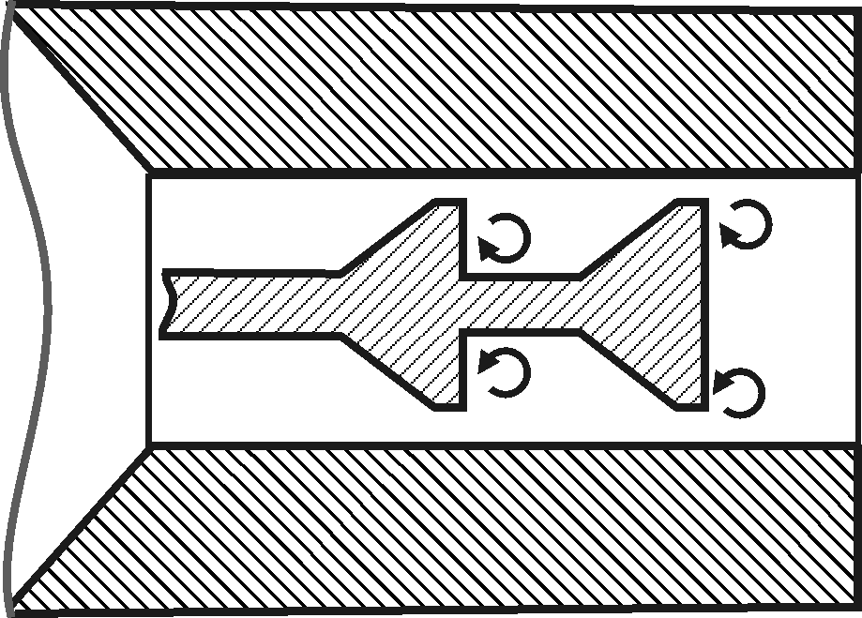
(B)
(C)
(A)

Figure 7. Schematic presentation of the used processing elements with gap-width of 395 μm: (A) Element with two cones, GW395-2C; (B) Element with single cone, GW395-1C; (C) Element with single cone of double length, GW395-1CDL.

The role of oil viscosity was studied with silicone oils having viscosity between 50 and 1000 mPa.s. The emulsification of silicone oils with viscosity below 600 mPa.s was successful (micrometer sized drops were obtained), whereas the silicone oils with higher viscosity could not be entirely dispersed into small drops (millimeter sized drops were observed in the final emulsion). This experimental fact is explained by comparing the drop residence time with the drop deformation time in the processing element. For successful emulsification, the residence time should be around 10 times longer than the deformation time.
The role of the viscosity of aqueous phase is studied by adding thickening agent (glycerol). The increased viscosity of the aqueous phase leads to changing the regime of emulsification from inertial turbulent to viscous turbulent. The experimental results for the mean drop size in emulsions produced in viscous turbulent flow are fitted with appropriate equation. The volumes, in which the main dissipation of turbulent energy takes place, were found to be similar for emulsification in inertial viscous and inertial turbulent regimes.

2.7. Conditions for creating thin liquid layers at the contact surface of two other liquids
(Paper published in the Proceedings of ICTAM 2004, Warsaw, August 2004)
Research Problem: Emulsification by liquid jet break-up: drop size distribution
Partner group: Warsaw
The design of new technologies, making it possible to manufacture the nano - structured materials is one of the most important tasks of the contemporary materials science. The technologies, utilizing the emulsion droplets as templates for producing nano - structures out of solid particles, suspended in the liquid phase, seem very promising; work on developing such technologies is progressing fast [1]. It seems however conceivable, that even smaller structures could be obtained, if instead of solid particles a liquid film was utilized. In the present research we investigate the conditions necessary for producing a liquid film at the interface of two non-mixing liquids.
To simulate the behavior of the three liquids the Molecular Dynamics simulation technique is applied using the program MOLDY [2]. Since, at the molecular level, the behavior of the liquids depends, in the first place, on the interaction potentials between the molecules [3], we look for the combination of the interaction potentials, which might produce the required liquid film at the surfaces of the emulsion droplets. We perform a number of simulation runs, assuming different interaction potentials. The liquids used for simulations are actually model liquids with desired properties, not the real ones. Still, the information, relevant for the technology, is obtained in this way. Having the information on the required interaction potentials one can look for the real liquids, fulfilling these requirements.
The aim of the preliminary calculations was to simulate formation of the liquid droplet in a vacuum and in another, non-mixing liquid. We placed a number of liquid molecules in a rectangular lattice and allowed them to move freely with velocities, corresponding to a prescribed temperature.
At the beginning we tried, for simplicity, to use the Simplified Water Model (SWM). A liquid of spherically symmetric molecules, interacting with each other only through the Lennard-Jones potential, the same as that for water, was considered. Such molecules, placed in a vacuum, spread uniformly in the whole simulation domain. To form a well-defined droplet it was necessary to use more realistic model of the water molecule (TIPS2, [4]), taking into account the electrostatic dipole interactions. Such interactions, on top of the Lennard-Jones potential, are the most important factor influencing the behaviour of water.
The initial configuration of the water molecules, taken for simulation, was actually very far from spherical. This produced oscillations of the shape of the droplet, visible for certain amount of time (Fig. 8). The frequency of these oscillations was comparable to the mean molecular speed divided by the diameter of the droplet.
To simulate the formation of a liquid droplet, immersed in another, non-mixing liquid, we first tried the SWM molecules, however without electrostatic dipole interactions certain amount of mixing was always present. To produce a liquid droplet successfully we had to immerse the SWM liquid, (which now could represent oil) in water described by the TIPS2 model.
Results of the simulation are quite reasonable allowing one to analyze physics of the two or three phase interactions of emulsions. Our present task is to perform simulations using larger number of molecules and to introduce interactions potential for the mixtures used in the CONEX experiments. See Annex 7 for details.

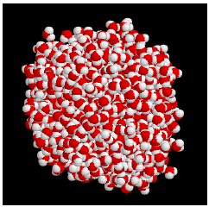
Figure 8. Water droplet in vacuum after ¼ of the oscillation period.
References
[1] S. Tcholakova, N. D. Denkov, D. Sidzhakova, I. B. Ivanov, B. Campbell: Interrelation between Drop Size and Protein Adsorption at Various Emulsification Conditions.
Langmuir, vol. 19, No. 14, 2003, 5640–5649.
[2] K. Refson: Moldy: a portable molecular dynamics simulation program for serial and parallel computers,
Comput. Phys. Commun. 126, 3, 2000, 309–328.
[3] M. P. Allen, D. J. Tildesley: Computer simulation of liquids, Clarendon Press, Oxford, 1987.
[4] W.L. Jorgensen, Revised TIPS model for simulations of liquid water and aqueous solutions.
J. Chem. Phys. 77, 1982, 4156–63.
[5] A. Słowicka, Z. A. Walenta, Conditions for creating thin liquid layers at the contact surface of two other liquids, ICTAM 2004 Abstracts Book and CD-ROM Proceedings, p.69, IPPT PAN Warsaw 2004 (Annex 7).

2.8. High-frequency linear viscosity of emulsions composed of two viscoelastic fluids
(Paper published in the Proceedings of ICTAM 2004, Warsaw, August 2004)
Research Problem: Emulsification by liquid jet break-up: drop size distribution
Partner group: Warsaw
We consider high-frequency linear viscoelastic response of an emulsion composed of viscoelastic drops suspended in another viscoelastic fluid. Typical examples of such systems include polymer blends and emulsions of polymeric solutions. Due to importance of viscoelastic fluids in chemical, pharmacological, and food industries, viscoelastic emulsion properties have been intensively studied theoretically and experimentally. For moderate drop volume fractions and viscosity ratios between the drop and continuous fluids simple analytical expressions for the effective viscosity of an emulsion have been developed. However, such approximations are inaccurate at high volume fractions of highly viscous drops.
In this work we focus on the frequency regime where the timescale associated with the frequency of the imposed flow is much smaller than the drop capillary relaxation time.
In this frequency regime the effect of the interfacial tension on drop dynamics can be neglected; yet, the system has nontrivial viscoelastic response due to the viscoelasticity of the component fluids. The drop deformation is assumed to be small at all times, and the response of the component fluids is linear.
Under the high-frequency assumption and small-deformation conditions the drops behave as nearly spherical viscoelastic fluid blobs with complex viscosity ratio. Due to the long capillary relaxation time the drops passively react to the imposed flow. We have derived explicit expressions for the function in terms of the spectrum of the operators characterizing hydrodynamic interactions of spherical drops. The expressions have been evaluated numerically for different volume fractions of randomly distributed drops. Our results allow calculating the effective viscosity of an emulsion with real values of the viscosity ratio.
Using Bergman spectral representation, we have developed a complete description of high-frequency effective viscosity for an emulsion of viscoelastic fluids. We have evaluated numerically the spectral density and the coefficients of the continued-fraction expansion (Fig. 9). With only several expansion levels, the continued fraction provides a very accurate analytical representation of the effective viscosity. The work is underway to extend this approach to the frequency regime, where the interfacial-tension effects are important.
Performed analysis can be used to predict behavior of emulsions applied in the CONEX experiments. See Annex 8 for details.
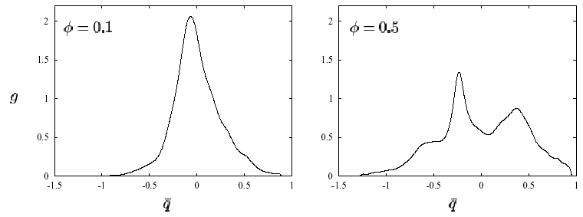
Figure 9. Spectral density, g, versus $\bar{q}=1−\frac{5}{2}q$ for two volume fractions, φ (as labeled).

References
[1] D. J. Bergman. Physical properties of macroscopically inhomogeneous media. In H. Ehrenreich and D. Turnbull, editors, Solid State Physics, vol. 46, page 37. Academic Press, New York, 1992.
[2] B. Cichocki and B. U. Felderhof. Periodic fundamental solution of the linear Navier-Stokes equations. Physica A, 159: 19-27, 1989.
[3] J. Blawzdziewicz, E. Wajnryb, High-frequency linear viscosity of emulsions composed of two viscoelastic fluids, ICTAM 2004 Abstracts Book and CD-ROM Proceedings, p.91, IPPT PAN Warsaw 2004 (Annex 8).

2.9. Production of emulsions in shear flow, experimental study
Research Problem: Drop-drop interaction in turbulent flow: direct observation of drop break-up and coalescence by a high-speed camera
Partner group: Warsaw
The deformation and disintegration of oil droplets in water are investigated experimentally and numerically to estimate well-controlled conditions form production of emulsions. The phenomenon of disintegration of droplets depends on the boundary conditions of the interface between carrier fluid and the droplet fluid. The types of conditions when the liquid droplet deform and disintegrate are classified according to experimental observations to several modes: vibrational, stripping and catastrophic. The last one describes turbulent flow disintegration.
Once size of the droplets becomes small enough, the two-liquid system converts to the quasi-stable mixture called emulsion. Two main factors are responsible for the mechanical droplet break-up: the flow shear stress at the interface trying to deform it and the interfacial tension opposing droplet deformation. Reducing surface tension by surfactants is one of the most common methods allowing one to obtain micro-emulsions at reasonable energy supply. For oil-water mixtures the surface tension due to the presence of surfactant is typically 10⁻² to 10⁻⁴ times lower than surface tension of pure oil-water interface.
In the framework of the project a simple shear flow induced emulsifier, developed at University of Sofia is used. It consists of a small channel formed between two glass plates and separated by a triangular obstacle (Fig. 10)

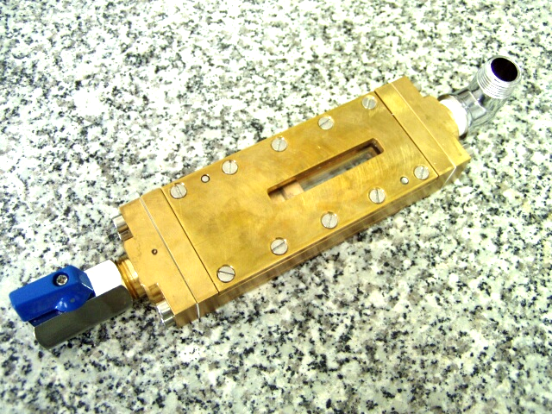 | 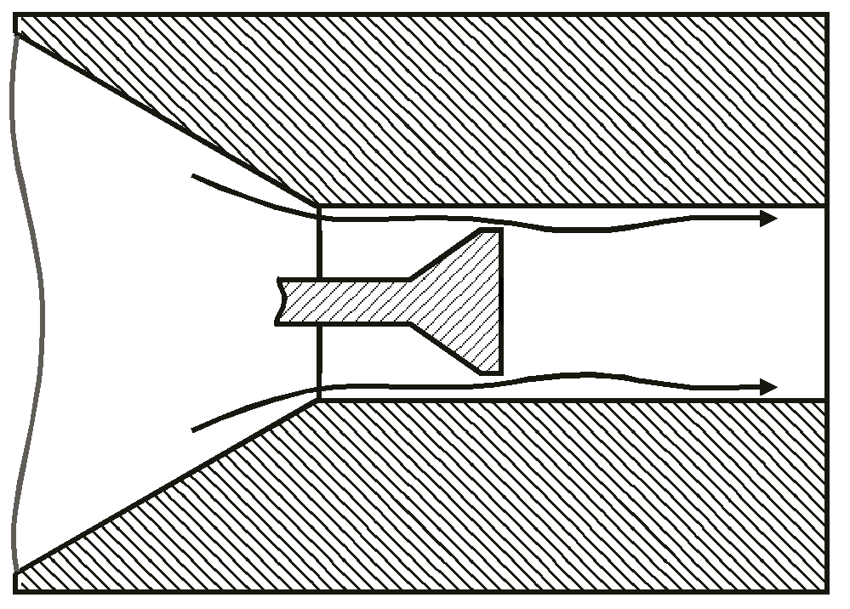
(a) | (b)
Figure 10. Experimental cell of the emulsifier: photography (a) and draft of the processing element inside the cell (b).

Due to the very small dimensions of the channel and microscopic scale of the flowing media standard observation techniques used in the fluid mechanics fail. Hence, for evaluation of droplets size and their velocity a micro-resolution particle image velocimetry (micro-PIV) system has been developed. It permits measurements of instantaneous flow fields in micron–scale fluidic devices for particle dimensions smaller then light wavelength (500nm). It is made possible by using for particles observation laser induced fluorescence, instead of direct particle scattering. Particle Image Velocimetry (PIV) based on correlation of pairs of images is used to evaluate instantaneous velocity field in the channel. These full field data allow for evaluation of local velocity gradients, hence for estimation of conditions for the droplet break-up. The full field velocity measurements will be also used to validate the numerical simulations performed for the experimental geometry and flow conditions. Such simulations allow, after their validation, a parametric study of the process and optimization of the emulsifier geometry.
To obtain additional information about the flow structure a three-dimensional numerical simulation for the investigated experimentally flow and geometry parameters were performed. Figure 11a shows configuration of the cell geometry with marked inlets and outlet, which was used for numerical simulation. Figure 11b shows generated mesh in central plane of the experimental cell (only part around processing element). The commercial code Fluent 6.1.22 was used to generate velocity fields and to visualize the flow paths.

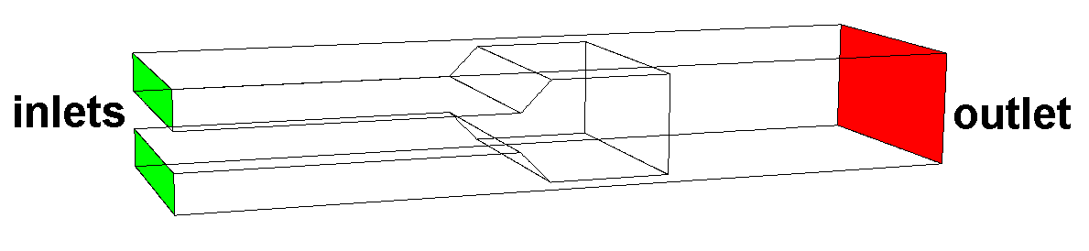 | 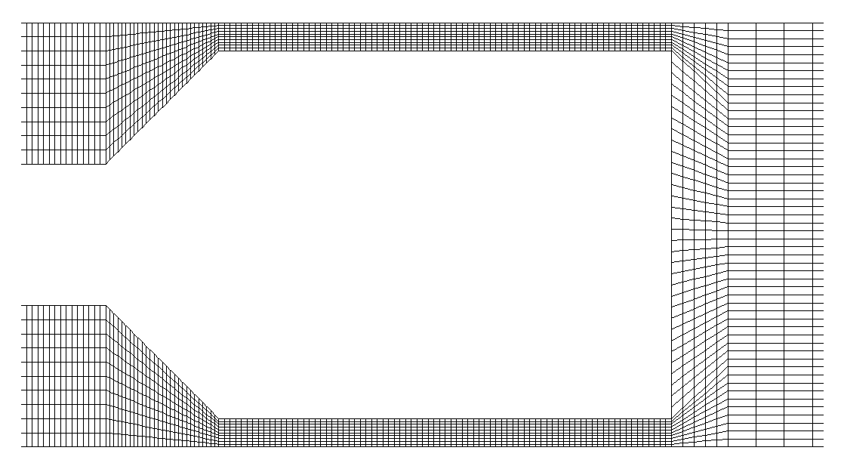
(a) | (b)
Figure 11. Schematic model of the experimental cell (a) and part around processing element of generated mesh (b).

Our preliminary study has shown applicability of the apparatus for analysis of the flow of emulsion in the microscopic channels. Further work is in progress to improve velocity field evaluations method. At the moment the main problem met during present experiments was damage of the microscope lenses by high-energy light pulses of Nd-Yag laser used for the flow field illumination. Short, high-energy light pulses are necessary “to freeze” motion of particles observed at high magnification of the microscope. Sharp images of fast moving fluorescent tracers are necessary for the PIV velocity evaluation. It appeared that additional effort has to be done to protect the optical system. See Annex 9 for details.

3. Publications and Papers
As mentioned above, a part of the results produced during the first year of our CONEX Project have been presented in the form of four scientific publications, which have been submitted to scientific journals or already appeared in the proceedings of international conference, as follows:
1. P. A. Kralchevsky, K. D. Danov, V. L. Kolev, T. D. Gurkov, M. I. Temelska, and G. Brenn, “Detachment of Oil Drops from Solid Surfaces in Surfactant Solutions: Molecular Mechanisms at a Moving Contact Line”, Industrial & Engineering Chemistry Research 44 (2005) – in press (Annex 2).
2. K. D. Danov, P. A. Kralchevsky, B. N. Naydenov, and G. Brenn, “Interactions between Particles with an Undulated Contact Line at a Fluid Interface: Capillary Multipoles of Arbitrary Order”, J. Colloid Interface Sci. – submitted September 19, 2004 (Annex 3).
3. A. Słowicka, Z. A. Walenta, “Conditions for Creating Thin Liquid Layers at the Contact Surface of Two Other Liquids”, ICTAM 2004 Abstracts Book and CD-ROM Proceedings, p.69, IPPT PAN Warsaw 2004 (Annex 7).
4. J. Blawzdziewicz, E. Wajnryb, “High-Frequency Linear Viscosity of Emulsions Composed of Two Viscoelastic Fluids”, ICTAM 2004 Abstracts Book and CD-ROM Proceedings, p.91, IPPT PAN Warsaw 2004 (Annex 8).
In all these publications, the financial support of the CONEX Program has been thankfully acknowledged.

4. Project Management
4.1. Organization of the Cooperation. The period between October 20, 2003 and October 19, 2004 was the first year of our project. In our work, we followed the planning and distribution of the tasks among the 3 partner groups, as formulated in the Proposal. The organization of the work was additionally specified during the Kick-off Meeting, which took place at the LCPE in Sofia between Friday, October 31 and Sunday, November 2, 2003. Regular contacts between the partners were realized mostly through exchanges of e-mails, printed materials and experimental results, as well as during the research period of Mrs. Slavka Tcholakova (from Sofia) in Warsaw. During the second project year, the basic directions of our activities have been:
- Experimental measurements to understand the mechanism of emulsification by narrow-gap homogenizer and the membrane emulsification;
- Theoretical and computer modeling of the investigated processes and phenomena, and test of the models against experimental data;
- Exchange of preliminary results between the 3 academic groups;
- Overview of the obtained results and preparation of publications.
4.2. The Kick-off Meeting took place at the University of Sofia, Bulgaria, between October 31 and November 2, 2003. The following representatives of the partner groups participated:
- IFDHT, Graz University of Technology (Austria): Prof. Dr. Günter Brenn (Coordinator), and Dr. Helfried Steiner;
- DMPF, Polish Academy of Sciences, Warsaw (Poland): Prof. Dr. Tomasz Kowalewski;
- LCPE, University of Sofia (Bulgaria): Prof. Peter Kralchevsky, Prof. Ivan B. Ivanov, Prof. Krassimir Danov, Assoc. Prof. Theodor Gurkov, Assistant Prof. Krastanka Marinova, Ph.D. Student Slavka Tcholakova, and the other members of the team in Sofia.
Below we present the Schedule of the Kick-off Meeting. First we started with presentations about the work and the obtained results by the separate groups. In fact, this was a small scientific symposium with 7 presentations. There was a discussion after each talk, focusing not only on scientific details, but also on their applicability. Next, we continued the Organizational Meeting with discussions between separate groups of partners about specific tasks of the research cooperation.

Schedule of the Kick-off Meeting in Sofia, October 31 – November 2, 2003

Friday, 31 October 2003
TIME | ACTIVITY
Chairmen: Günter Brenn
15:10–15:20 | Günter Brenn, Opening words
15:20–17:20 | Ivan B. Ivanov, Theory of emulsification in turbulent regime
17:20–17:40 | Coffee Break
Chairmen: Tomasz Kowalewski
17:40–18:05 | Slavka Tcholakova, Emulsification: comparison of experiment and theory
18:05–18:35 | Peter Kralchevsky, Thermodynamic aspects of particles at interfaces and membrane emulsification
18:35–19:00 | Krassimir Danov, Hydrodynamic aspects of membrane emulsification
19:00→ | Dinner

Saturday, 1 November 2003
8:30–10:00 | Lab tour (Guide: Dr. Krastanka Marinova)
Chairmen: Ivan B. Ivanov
10:00–11:20 | Günter Brenn, Results related to the Project and research tasks for the team in Graz (tentative title)
11:20–12:40 | Tomasz Kowalewski, Results related to the Project and research tasks for the team in Warsaw (tentative title)
12:40–14:00 | Lunch
14:00–19:00 | General Discussion
19:00→ | Dinner

Sunday, 2 November 2003
10:00–12:00 | Discussion of Profs. Ivanov and Kowalewski about experiments.
12:00–13:00 | Lunch
14:40 | Departure Prof. Kowalewski

According to our plan, the Second Project Meeting will take place in Warsaw, October 28–31, 2004.

4.3. Mobility. During the first project year, three short visits and one two-week stay of a young researcher in a partner laboratory were realized, as follows:
Prof. Günter Brenn (Graz), four days in Sofia (30.10 – 02.11.2003);
Dr. Helfried Steiner (Graz), four days in Sofia (30.10 – 02.11.2003);
Prof. Tomasz Kowalewski (Warsaw), four days in Sofia (30.10 – 02.11.2003);
Mrs. Slavka Tcholakova, Ph.D. student (Sofia), 20 days in Warsaw (15.08 – 03.09.2004)
The first three visits are related to the Kick-off Meeting.
The purpose of the visit of Mrs. Slavka Tcholakova in Warsaw was to carry out joint experiments on emulsification. The narrow-gap homogenizer was brought from Sofia to Warsaw, where observations of the emulsification process in situ, by a high-speed video camera were carried out. The obtained results are described in Annexes No. 5 and 9. Mrs. Tcholakova also took part in the 21st International Congress of Theoretical and Applied Mechanics (ICTAM), August 15-21, 2004 (organized by Prof. T. Kowalewski).
In the nearest future, short visits of representatives of the groups in Graz and Sofia to Warsaw are planned in relation to the Second Project Meeting. Furthermore, 1 week visit of Professor K. Danov from Sofia group to Graz, Austria, for hydrodynamic computations (first week of December, 2004) will take place.

4.4. Reporting of the Project Results at Scientific Conferences and Symposia. The produced results have been reported at the following conferences:
- A. Słowicka, Z. A. Walenta, Conditions for creating thin liquid layers at the contact surface of two other liquids, 21st International Congress of Theoretical and Applied Mechanics (ICTAM) August 15-21, 2004 (oral presentation).
- J. Blawzdziewicz, E. Wajnryb, High-frequency linear viscosity of emulsions composed of two viscoelastic fluids, 21st International Congress of Theoretical and Applied Mechanics (ICTAM) August 15-21, 2004 (oral presentation).
- S. Tcholakova, N. D. Denkov, I. B. Ivanov and T. Danner, Main factors controlling the emulsification process under turbulent conditions. Experiment and data interpretation, 21st International Congress of Theoretical and Applied Mechanics (ICTAM) August 15-21, 2004 (poster).
- N. D. Denkov, S. Tcholakova, I. B. Ivanov, N. Vankova, T. Danner, Main factors controlling emulsification in turbulent flow, Conference on Physics and Design of Foams, Unilever R&D, Edgewater, New Jersey, July 22-23, 2004 (poster).

4.5. Involvement of young scientists
In IFDHT, Graz, Austria – 1 young scientist (postdoc) was involved in the research on the project
LCPE, Sofia, Bulgaria – 4 young scientists took part in the research on the Project: The Ph.D. Candidates, Mrs. Slavka Tcholakova and Miss Nina Vankova, carried out the experiments with the narrow-gap homogenizer and took part in the related data interpretation; The Ph.D. Candidate, Mr. Vesselin Kolev, took part in the data acquisition and processing in the study on oil-drop-detachment described in Annex 2; he is a coauthor of the respective paper. The Ph.D. Candidate, Mr. Nikolai Christov, is performing experiments on membrane emulsification, which will be completed and presented in the next report.
DMPF, Warsaw, Poland – 2 Ph.D. students

4.6. Involved scientifically qualified females
IFDHT, Graz, Austria - 1 scientifically qualified female (Ph.D. by date of project start)
In LCPE–Sofia, 9 qualified females participated in the work on the project. The names of Mrs. Slavka Tcholakova and Miss Nina Vankova have been just mentioned. Mrs. Tcholakova was very active in the project; she took part in the international cooperation and spent 20 days in the Polish Academy in Warsaw. Ms. Nina Vankova is making her Ph.D. thesis on the subject of the present thesis (emulsification). In addition, Mrs. Mila Temelska carried out most of the experiments on oil-drop detachment described in Annex 2; she is a coauthor of the respective paper. Six other qualified females took part in separate experiments: Dr. Krastanka Marinova; Mrs. Elka Basheva; Mrs. Stefka Kralchevska; Mrs. Cenka Pishmanova; Mrs. Dora Todorova and Miss Elena Kostova,
DMPF, Warsaw, Poland – 1 postdoc and 2 Ph.D. students

4.7. EU Proposals
The groups in Graz and Sofia applied jointly with other 15 teams from 13 European countries for a COST Project entitled: “Physics of Drops”.
(see details at http://www.ulg.ac.be/grasp/cost.html)

5. Conclusion
In summary, the results of the groups in Graz, Sofia and Warsaw produced during the first CONEX Project year, led to the presentation of 3 communications at conferences, and to the publication of 4 scientific papers (see sections 3 and 4.4). In addition, many new results, of both scientific and applied interest, have been produced and reported in Annexes № 1, 4, 5, 6, and 8. Their completion during the second project year will result in several new joint scientific publications. The work during the second project year will continue in accordance with the plan presented in our Proposal.

