Emulsions with Nanoparticles for New Materials
(EMMA)

Contract GZ 45.534/1-VI/6a/2003 of the CONEX Project

Final Scientific and Management Report

Presented by

O. Univ.-Prof. Dr. Günter Brenn, Project Coordinator

Partners:
- Institute of Fluid Dynamics and Heat Transfer (IFDHT), Graz University of Technology, Graz, Austria (O. Univ.-Prof. Dr. Günter Brenn)
- Laboratory of Chemical Physics and Engineering (LCPE), Faculty of Chemistry, University of Sofia, Sofia, Bulgaria (Prof. Dr. Peter A. Kralchevsky)
- Department of Mechanics and Physics of Fluids (DMPF), Warsaw, Polish Academy of Sciences (Prof. Dr. Tomasz A. Kowalewski)

Contents
1. Objectives | 2
2. Activities and Results Achieved | 2
2.1. Numerical simulation and experimental study of emulsification in a narrow-gap homogenizer | 4
2.2. Comparison of the mean drop size in emulsions, prepared in the cylindrical and planar narrow-gap homogenizers | 6
2.3. Production of emulsions in shear flow: experimental and numerical study. Breakup of liquid jet in co-flow: experimental study | 7
2.4. Linear temporal stability analysis of a liquid filament in a laminar pipe flow of another immiscible liquid | 10
2.5. Creating a thin liquid layer at the contact surface of two other liquids | 11
2.6. Electric forces induced by a charged colloid particle attached to the interface water–nonpolar fluid | 12
2.7. Shape of the capillary meniscus around an electrically charged particle at a fluid interface: Comparison of theory and experiment | 13
2.8. Hydrodynamic theory of drop detachment from micro-pores with application to membrane emulsification | 16
3. Publications and Papers | 18
4. Project Management | 19
5. Conclusion | 24
1. Objectives
As stated in our Proposal, the main purpose of the joint work in this project is to explore several new and promising directions for fabrication of nano-composites (colloidosomes, microcapsules, core-shell and other composite particles), as well as nano-structured surfaces and porous layers by using emulsion droplets as precursors and/or templates. The procedures involve the formation of emulsions, and especially – emulsions stabilized by solid particles. Therefore, a large fraction of our efforts are directed to reveal the main factors governing the process of emulsification and the emulsion stability in the presence of solid particles. For our experiments, we selected three emulsification methods, viz. (i) narrow-gap homogenizer; (ii) liquid jet break-up and (ii) membrane emulsification. Our first goal is to produce experimental data and theoretical model, and to compare them with respect to the size distribution of the produced drops. The next step is to investigate the interaction of nanoparticles at interfaces that lead to the formation of dense adsorption layers and formation of stable Pickering emulsions. To understand the underlying processes and mechanisms, we are carrying out both emulsification experiments and model experiments with single drops, which allow direct optical observation and quantitative analysis of the processes (such as kinetics of particle adsorption, film stability and drop-drop coalescence, etc.). In parallel, theoretical models directed to explain the observed dependencies and to reveal the main factors that control the emulsification process are developed and tested against the emulsification and model experiments. The results obtained during the second project year are summarized below, in accordance with our research plan.

2. Activities and Results Achieved
We present the activities undertaken and the results achieved, following the separate tasks formulated in our proposal. The contributions of the three groups are denoted with the name of the city: Graz, Sofia and Warsaw. Some of the studies are denoted as joint studies because they contain comparable contributions from two groups. However, as seen in the abstracts below, most of the studies have been promoted by the cooperation within the frame of the Project: experimental setups assembled by one of the groups have been used by another group; theoretical methods developed by one of the partners have been applied by another partner. Our results during the first project year are summarized in Table 1. After that, we present the abstracts of the Sections of this Report. The Sections themselves are appended as Annexes.

Table 1. Results obtained during the Second Project Year
№ | Partner Groups | Research Problem | Annex to the Report | Result: Title of the Annex
1. | Graz & Sofia | Theory and experiment on turbulent flow in cylindrical narrow-gap homogenizer | Annex 1 | Numerical simulation and experimental study of emulsification in a narrow-gap homogenizer
2. | Sofia | Experiment on comparison of the cylindrical and planar narrow-gap homogenizer | Annex 2 | Comparison of the mean drop size in emulsions, prepared in the cylindrical and planar narrow-gap homogenizers
3. | Warsaw | Experiment and numerical simulation of emulsification by planar narrow-gap homogenizer and liquid jet break-up | Annex 3 | Production of emulsions in shear flow: experimental and numerical study. Breakup of liquid jet in co-flow: experimental study
4. | Graz & Warsaw | Theory of emulsification by liquid jet break-up | Annex 4 | Linear temporal stability analysis of a liquid filament in a laminar pipe flow of another immiscible liquid
5. | Warsaw | Molecular simulation of films that protect emulsion drops against coalescence | Annex 5 | Creating a thin liquid layer at the contact surface of two other liquids
6. | Sofia | Theory of particle interaction in an adsorption layer in relation to the fabrication of core-shell particles and colloidosomes | Annex 6 | Electric forces induced by a charged colloid particle attached to the interface water–nonpolar fluid
7. | Sofia | Theory and experiment on particles at interfaces in relation to the fabrication of core-shell particles and colloidosomes | Annex 7 | Shape of the capillary meniscus around an electrically charged particle at a fluid interface: Comparison of theory and experiment
8. | Sofia | Theoretical analysis of membrane emulsification | Annex 8 | Hydrodynamic theory of drop detachment from micro-pores with application to membrane emulsification
Below, we briefly describe the obtained results following the order of the results given in Table 1. Details can be found in the Annexes, which represent an integral part of this report (see Table 1).
2.1. Numerical simulation and experimental study of emulsification in a narrow-gap homogenizer
Research Problem:
Theory and experiment on turbulent flow in cylindrical narrow-gap homogenizer
Partner groups: Graz & Sofia (see Annex 1 for details)

Abstract: The present experimental and theoretical study investigates the fragmentation of the oil phase in an emulsion on its passage through a high-pressure, axial-flow homogenizer. The considered homogenizer channel contains narrow annular gaps, whereupon the emulsion emerges with a finer dispersed oil phase. The experiments were carried out using either a facility with one or two successive gaps, varying the flow rate and the material properties of the dispersed phase (Figure 1.1). The measured drop size distributions in the final emulsion clearly illustrated that the flow rate, as well as the dispersed-phase viscosity, and the interfacial tension can significantly affect the drop size after emulsification. The always-larger mean and maximum drop diameters obtained for the homogenizer with one gap in comparison to those obtained with two gaps, at the same Reynolds number, highlighted the strong relevance of the flow geometry to the emulsification process.
Fig. 1.1: Flow rate Q as a function of the applied driving overpressure, p_{ov}, for the processing elements with one gap and two gaps. The symbols are experimental data from independent runs, whereas the curves are empirical fits (Q in 10^{–3}m³s^{–1}as a best-fit function of p_{ov} in Pa).

ε (m²s⁻³)  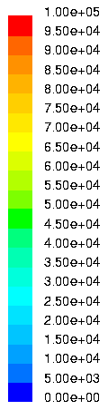 | 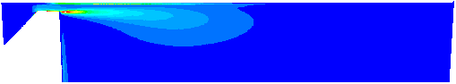  (a) one gap, Q = 0.092 ּ10⁻³m³s⁻¹  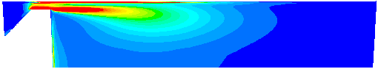  (b) one gap, Q = 0.145 ּ10⁻³m³s⁻¹  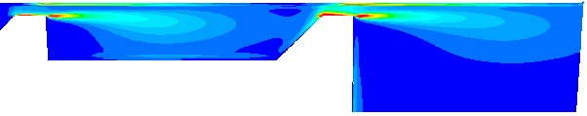  (c) two gaps, Q = 0.092 ּ10⁻³m³s⁻¹  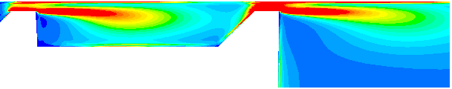  (d) two gaps, Q = 0.145 ּ10⁻³m³s⁻¹

Fig. 1.2: Contours of the turbulent dissipation rate ε (m²s⁻³) for both computed geometries and flow rates. For a better distinguishing the individual levels of ε, the ε-scale is clipped, such that regions with ε > 10⁵ m²s⁻³ appear as dark red areas.

The numerical simulation of the carrier phase flow fields evolving in the investigated homogenizer was proven to be a very reliable method for providing appropriate input to theoretical models for the maximum drop size. The predictions of the applied droplet breakup models using input values from the numerical simulations showed very good agreement with the experimental data. In particular, the effect of the flow geometry - one-gap versus two-gaps design - was captured very well (Figure 1.2). This effect associated with the geometry is missed completely when using instead the frequently adopted concept of estimating input values from very gross correlations. It was shown that applying such a mainly bulk flow dependent estimate correlation makes the drop size predictions insensitive to the observed difference between the one-gap and the two-gaps cases. This obvious deficit, as well the higher accuracy, strongly favors the present method relying on the numerical simulation of the carrier phase flow. (See Annex 1 for details)

2.2. Comparison of the mean drop size in emulsions, prepared in the cylindrical and planar narrow-gap homogenizers
Research Problem:
Experiment on comparison of the cylindrical and planar narrow-gap homogenizers
Partner group: Sofia (see Annex 2 for details)

Cylindrical homogenizer

Q = 3.293x10⁻⁴p^{0.527}

(A)

Q = 2.950 x 10⁻⁴p^{0.563}

Planar homogenizer

Q = 2.950 x 10⁻⁴p^{0.563}

(B)

Figure 2. Flow rate, Q, as a function of the applied pressure, p, for processing elements with: (A) cylindrical symmetry, and (B) planar symmetry. The symbols are experimental data, whereas the curves are empirical fits.
Abstract: The main goal of this study is to obtain experimental information about the mean drop size in emulsions prepared in cylindrical and planar narrow-gap homogenizers at comparable conditions (equal Reynolds numbers); see Figure 2.
Experimental results are obtained for the mean drop size after emulsification at various conditions – two geometries of the processing element, two Reynolds numbers, two viscosities of the oil phase, three interfacial tensions (Figure 2). The obtained set of results can be used for comparison with the numerical simulations performed by the partners from Graz and Warsaw.
- The results show that the effects of oil viscosity, interfacial tension, and Reynolds number are very important for the mean drop size – all these factors should be taken into account when comparing estimating theoretically the drop size during emulsification in the studied homogenizers.
- The comparison of the results obtained with planar and cylindrical homogenizers shows that the mean drop size for the planar homogenizer is systematically (by 7 ± 2 %) larger than that for the cylindrical homogenizer at equivalent all other conditions. The possible reasons for this difference will be discussed during the final meeting of the Project, while comparing the numerical simulations with the experimental results by the partner groups. See Annex 2 for details.

2.3. Production of emulsions in shear flow: experimental and numerical study. Breakup of liquid jet in co-flow: experimental study
Research Problem: Experiment and numerical simulation of emulsification by planar narrow-gap homogenizer and liquid jet break-up
Partner group: Warsaw (see Annex 3 for details)
Abstract: Two experimental cases are investigated. In the first one, the breakup of oil droplets is studied in a shear flow (Figure 3.1). In the second case the capillary instability and generation of droplets is studied for liquid jet in co-flow of other immiscible liquid (Figure 3.2). The purpose of the investigations is to develop procedure for well-controlled generation of mono-dispersed emulsion of micro-droplets. These droplets will form a matrix for collection of nano-particles into well-structured configuration. In both experimental studies similar experimental setup and fluids are used.
The main part of the apparatus consists of microscope, channel with transparent windows, light source and digital camera. The shear flow dispersion of oil in water is studied for single processor emulsifier constructed by University of Sofia. The process is investigated experimentally and numerically to elucidate conditions for oil droplets break-up. The flat 2-D emulsifier is constructed to ease optical access, hence to permit application of optical methods for measuring flow velocity field (PIV method) and to visualize emulsion droplets. It is a two dimensional replica of the central cross-section of cylindrical emulsifier used in Sofia. Two slightly different versions of the plain emulsifier processing part are used. The main difference is in the length of a gap (comp. Fig. 3.1), being 1 mm or 2 mm. The 2 mm long gap has transparent section made of Plexiglas to permit back light illumination, necessary for droplet observations within the gap. In the following results are given for the geometry with 1mm long gap (G1) and with 2mm long gap (G2).

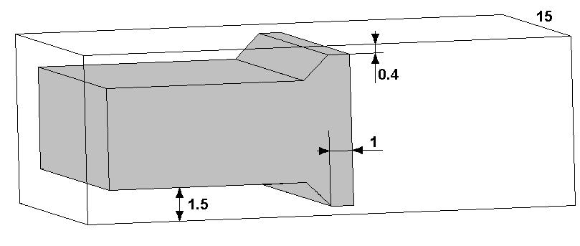 | 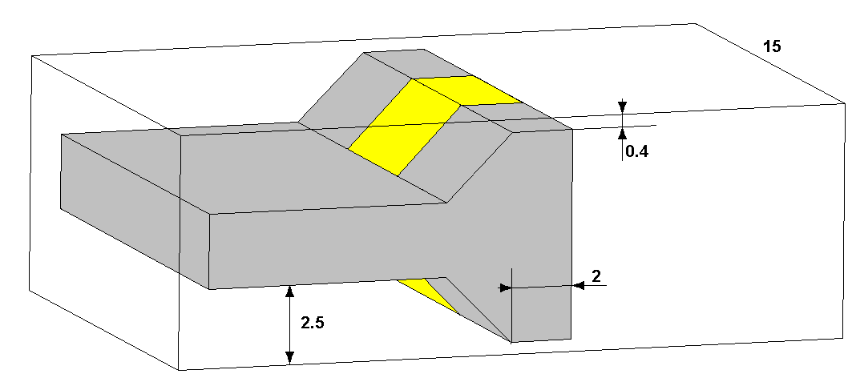
(a) | (b)
Fig. 3.1. Geometry of the processing element for two-dimensional emulsifier; (G1) 1mm gap length, (G2) 2mm gap length, processing element with the transparent widow. The gap height and width is 0.4mm and 15mm, respectively.

The jet breakup is studied in the rectangular cavity with two glass windows and cylindrical inlet and outlet channels. The carrier fluid (water or water alcohol mixture) is forced through the channel using precision stroke pump. The inlet opening is equipped with a 0.8mm syringe needle, to deliver in concentric way oil into the flow system. For details comp. Fig. 3.2.

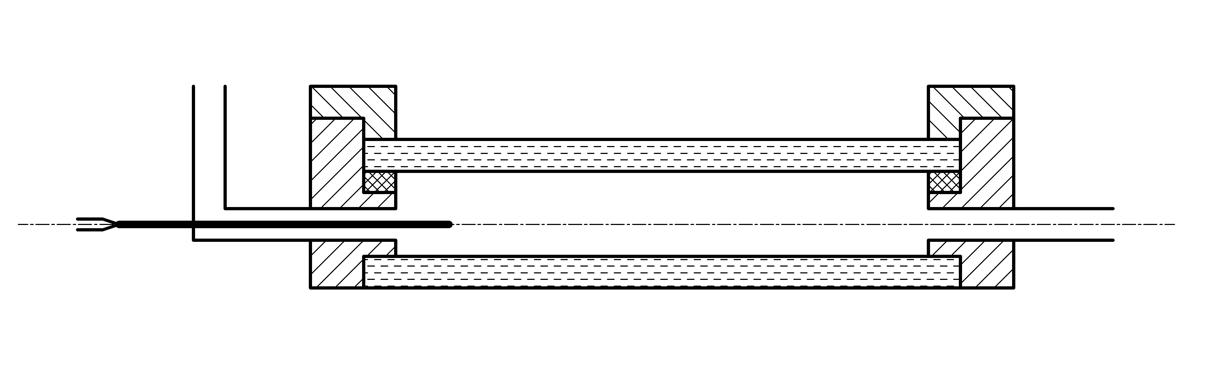
Fig. 3.2. Scheme of the channel for jet break-up observation (geometry G3). Oil jet is issued from the needle into co-flow of water-alcohol solution. Channel length 30mm, height 8mm, and width 10mm. The co-flow inlet diameter is 3mm. The needle external and internal diameter is 0.8mm and 0.5mm, respectively. The flow is illuminated through the bottom glass wall and observed through the upper glass wall.

(1) Velocity measurements (micro-PIV) indicate almost uniform velocity flow field in the gap region. It means that turbulence is still not fully developed and only strong shear gradients may be responsible for the droplet break-up. After processing element there is strong recalculation zone with a reversal flow. The turbulent fluctuations of the velocity field, break-up of the flow symmetry observed in this region indicate that here probably occurs transition from laminar to turbulent flow regime.
(2) Visualisation of droplets break-up in the homogenizer indicates that the process takes place within the gap or shortly before. We could not find “large” droplets in the gap. However, there are “large” droplets observed after the gap. It is not clear to us if these droplets are created due to the agglomeration in the dead-water region (re-circulation zone after the gap), or we couldn’t catch with our camera large droplets in the gap. The flow observations are performed in the vicinity of the channel centre only. It is possible that some large droplets are trapped by the sidewalls of the gap, invisible to the camera. They may enter the re-circulation zone, and being transported by a cross-flow to the centre become visible in the field of observation. It would indicate existence of a strong cross-flow in this region, in fact partly visible in our velocity field measurements.
(3) The capillary break-up of the liquid jet in co-flow is used to produce single droplets. Well-controlled production of single micro-droplets is necessary for studying accumulation of nano-particles at the interface, the main target of the project. The experiments performed indicated that small droplets (1um) are created as satellites during fluid-threads break-up. The process of a micro-thread formation was previously observed and investigated [Kowalewski, Fluid Dyn. Res. 1996] for break-up of viscous jets in air. Similar process is found in the present study for two-liquids system. A hydrodynamic separation of small satellites created after the thread break-up is perhaps the simplest method of utilizing jet break-up for micro-droplets production.
(4) Numerical modelling confirmed main details of the velocity flow field measured by the micro-PIV method (Figure 3.3). It gives confidence that generated numerical data can be applied for predicting conditions for droplets break-up in a shear flow. The laminar and turbulent flow models are successfully applied producing similar flow structure. It indicates that intensity of turbulence is relatively low and that the droplets break-up process may depend not only on the turbulent dissipation energy, but also mainly on the shear gradients of strongly fluctuating in time quasi-laminar flow field. (See Annex 3 for details)

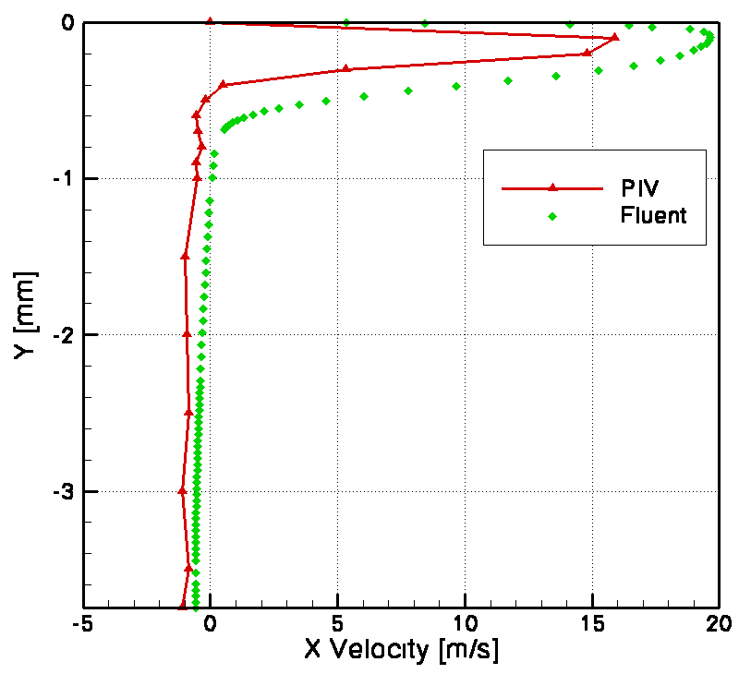  (a) | 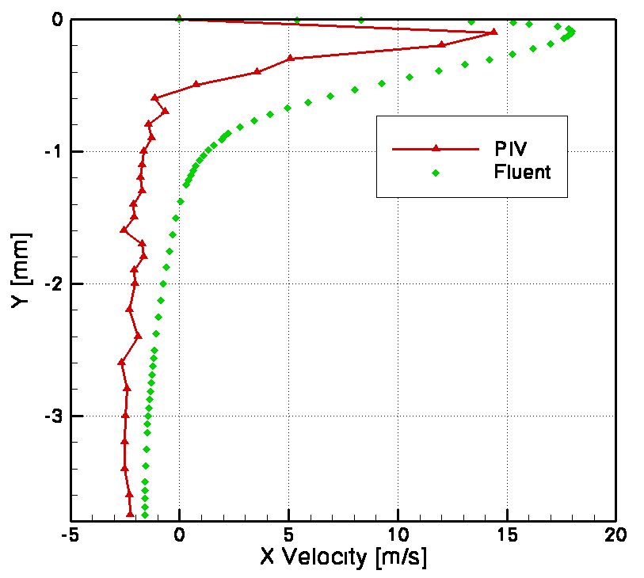  (b) | 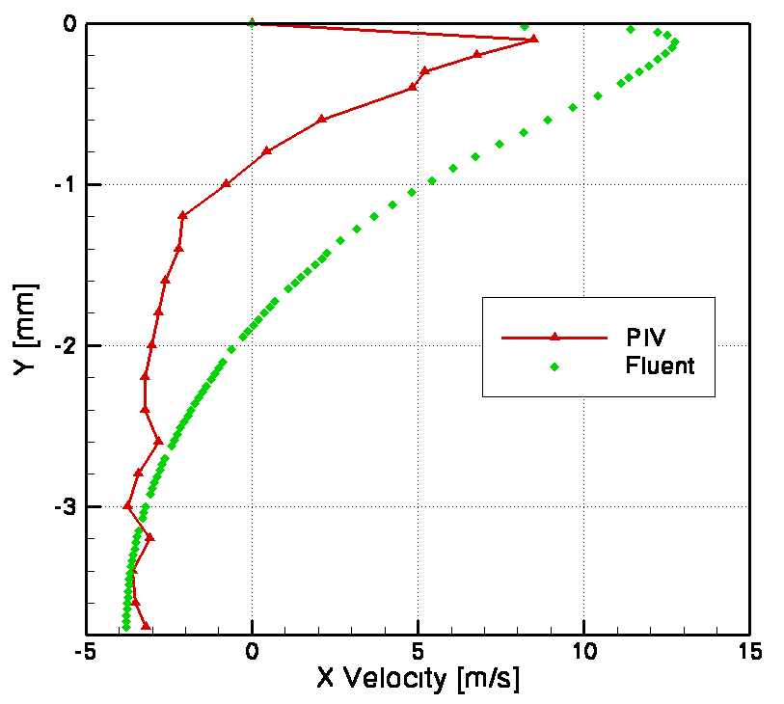  (c)
Fig. 3.3. Comparison of numerical and experimental x-velocity vertical profiles for selected regions in emulsifier: (a) 1 mm after processing element, (b) 3 mm, and (c) 8 mm.

2.4. Linear temporal stability analysis of a liquid filament in a laminar pipe flow of another immiscible liquid
Research Problem: Theory of emulsification by liquid jet break-up
Partner group: Graz & Warsaw (see Annex 4 for details)
Abstract: In emulsification processes, various techniques are in use for dispersing one liquid in another, immiscible liquid. Besides techniques relying on stirring, the action of ultrasound, and the effects of a turbulent flow of the two-phase mixture through a narrow gap, an important technique relies on the break-up of a thread of one liquid in a confined coaxial flow with the other liquid as the surrounding carrier fluid. Usually, an arrangement of many liquid jets in the carrier flow is produced by an array of nozzle holes. The geometry with a single jet is arrangement of a liquid cylinder in a confined coaxial pipe flow, so that the ambient flow does not extend to infinity. The jet breaks down due to its capillary instability and forms the droplets to be emulsified.
Fig. 4: Coaxial two-component liquid flow in a confined geometry.

The coaxial flow situation is described by the sketch in Fig. 4, which defines the properties of the inner and outer flows of the two liquids. The outer flow is the carrier liquid, and the inner one the liquid to be turned into droplets in order to be emulsified. The whole process takes place in a confined flow situation with the inner radius R of the tube, inside which the carrier liquid and a jet of the liquid to be emulsified move. As an alternative, one could certainly consider a case where the jet of liquid to be emulsified is ejected into an infinite bath of the carrier liquid.
The present study undertakes a linear temporal stability analysis of this flow and derives its dispersion relation. Predictions about the most probable drop size derived from the dispersion relation at the maximum growth rate of axisymmetric disturbances are compared with experimental data from the literature. (See Annex 4 for details)

2.5. Creating a thin liquid layer at the contact surface of two other liquids
Research Problem:
Molecular simulation of films that protect emulsion drops against coalescence
Partner group: Warsaw (See Annex 5 for details)
Abstract: The design of new technologies, making it possible to manufacture the nano – structured materials is one of the most important tasks of the contemporary materials science. The technologies, using the emulsion droplets as templates to produce nano-structures out of solid particles suspended in liquid phase are under development. It seems conceivable, that even smaller structures could be obtained if a liquid film was used instead of solid particles. In the present study we investigate the conditions necessary for producing such liquid film at the interface of two other, immiscible liquids.
In the investigated method of producing nanomaterials we used emulsion consisting of water and oil. Diameters of the oil droplets were very small, so we could not use the classical, continuum methods to describe processes in liquids. To simulate the behavior of the three liquids we applied the Molecular Dynamics simulation technique. For the detailed calculations we used the program “MOLDY”. For calculations the molecular model of water, TIPS2 was used. To test its behavior, formation of water droplet in vacuum was simulated. The molecules initially placed in a rectangular lattice, after some time created a spherical shape, and later the beginning of evaporation was observed.
To the test the oil molecules, formation of an oil droplet in water and water droplet in oil was simulated. The obtained oil droplet in water was more stable than the water droplet in oil, which agrees with macroscopic observations. To simulate interactions between three liquids we used the same models of water and oil. The third component was similar in its structure to soap, whose molecules consist of two parts – resembling the molecules of oil and water. After some modification of the model of the third component (increasing the length of its molecules), the thin film between layers of oil and water was obtained (Fig. 5). (See Annex 5 for details)

Fig.5. Thin film of „soap” between oil and water.

2.6. Electric forces induced by a charged colloid particle attached to the interface water–nonpolar fluid
Research Problem: Theory of particle interaction in an adsorption layer in relation to the fabrication of core-shell particles and colloidosomes
Partner group: Sofia (See Annex 6 for details)
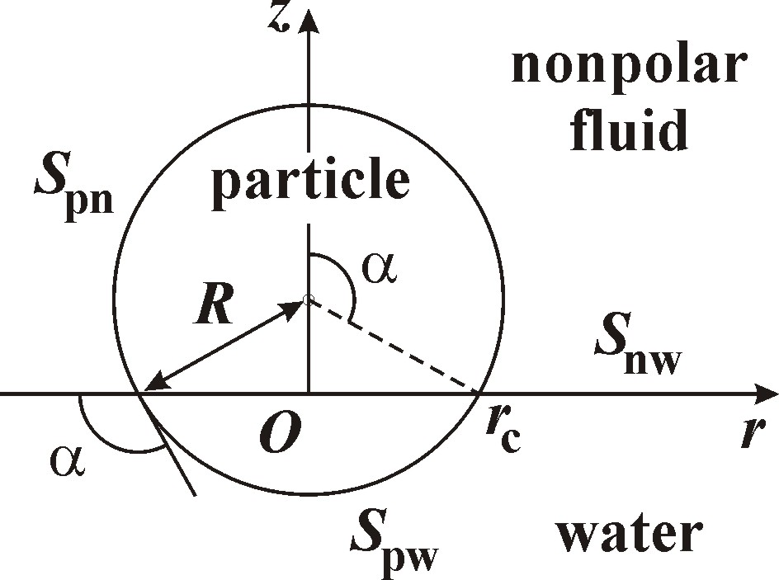
Fig. 6.1. In zero-order approximation, the interface water–nonpolar fluid, S_{nw}, is planar. S_{pn} and S_{pw} denote the interfaces particle–nonpolar fluid and particle–water, respectively.

Abstract: Our purpose here is to solve the theoretical problem about the electric field of a charged dielectric particle, which is adsorbed at the boundary water–nonpolar fluid (oil, air), see Figure 6.1. In accordance with the experimental findings, we consider the case when the surface charges are located at the boundary particle–nonpolar fluid. The symmetry of the system suggests the Mehler-Fock integral transform to be used for solving the electrostatic boundary problem. In the special case when the dielectric constants of the particle and the nonpolar fluid are equal, the solution is obtained in a closed analytical form. In the general case of different dielectric constants, the problem is reduced to the solution of a Fredholm integral equation, which can be carried out numerically, by iterations. The latter numerical procedure turns out to be much faster than the procedure for direct numerical integration of the original partial differential equations, which has been previously used.
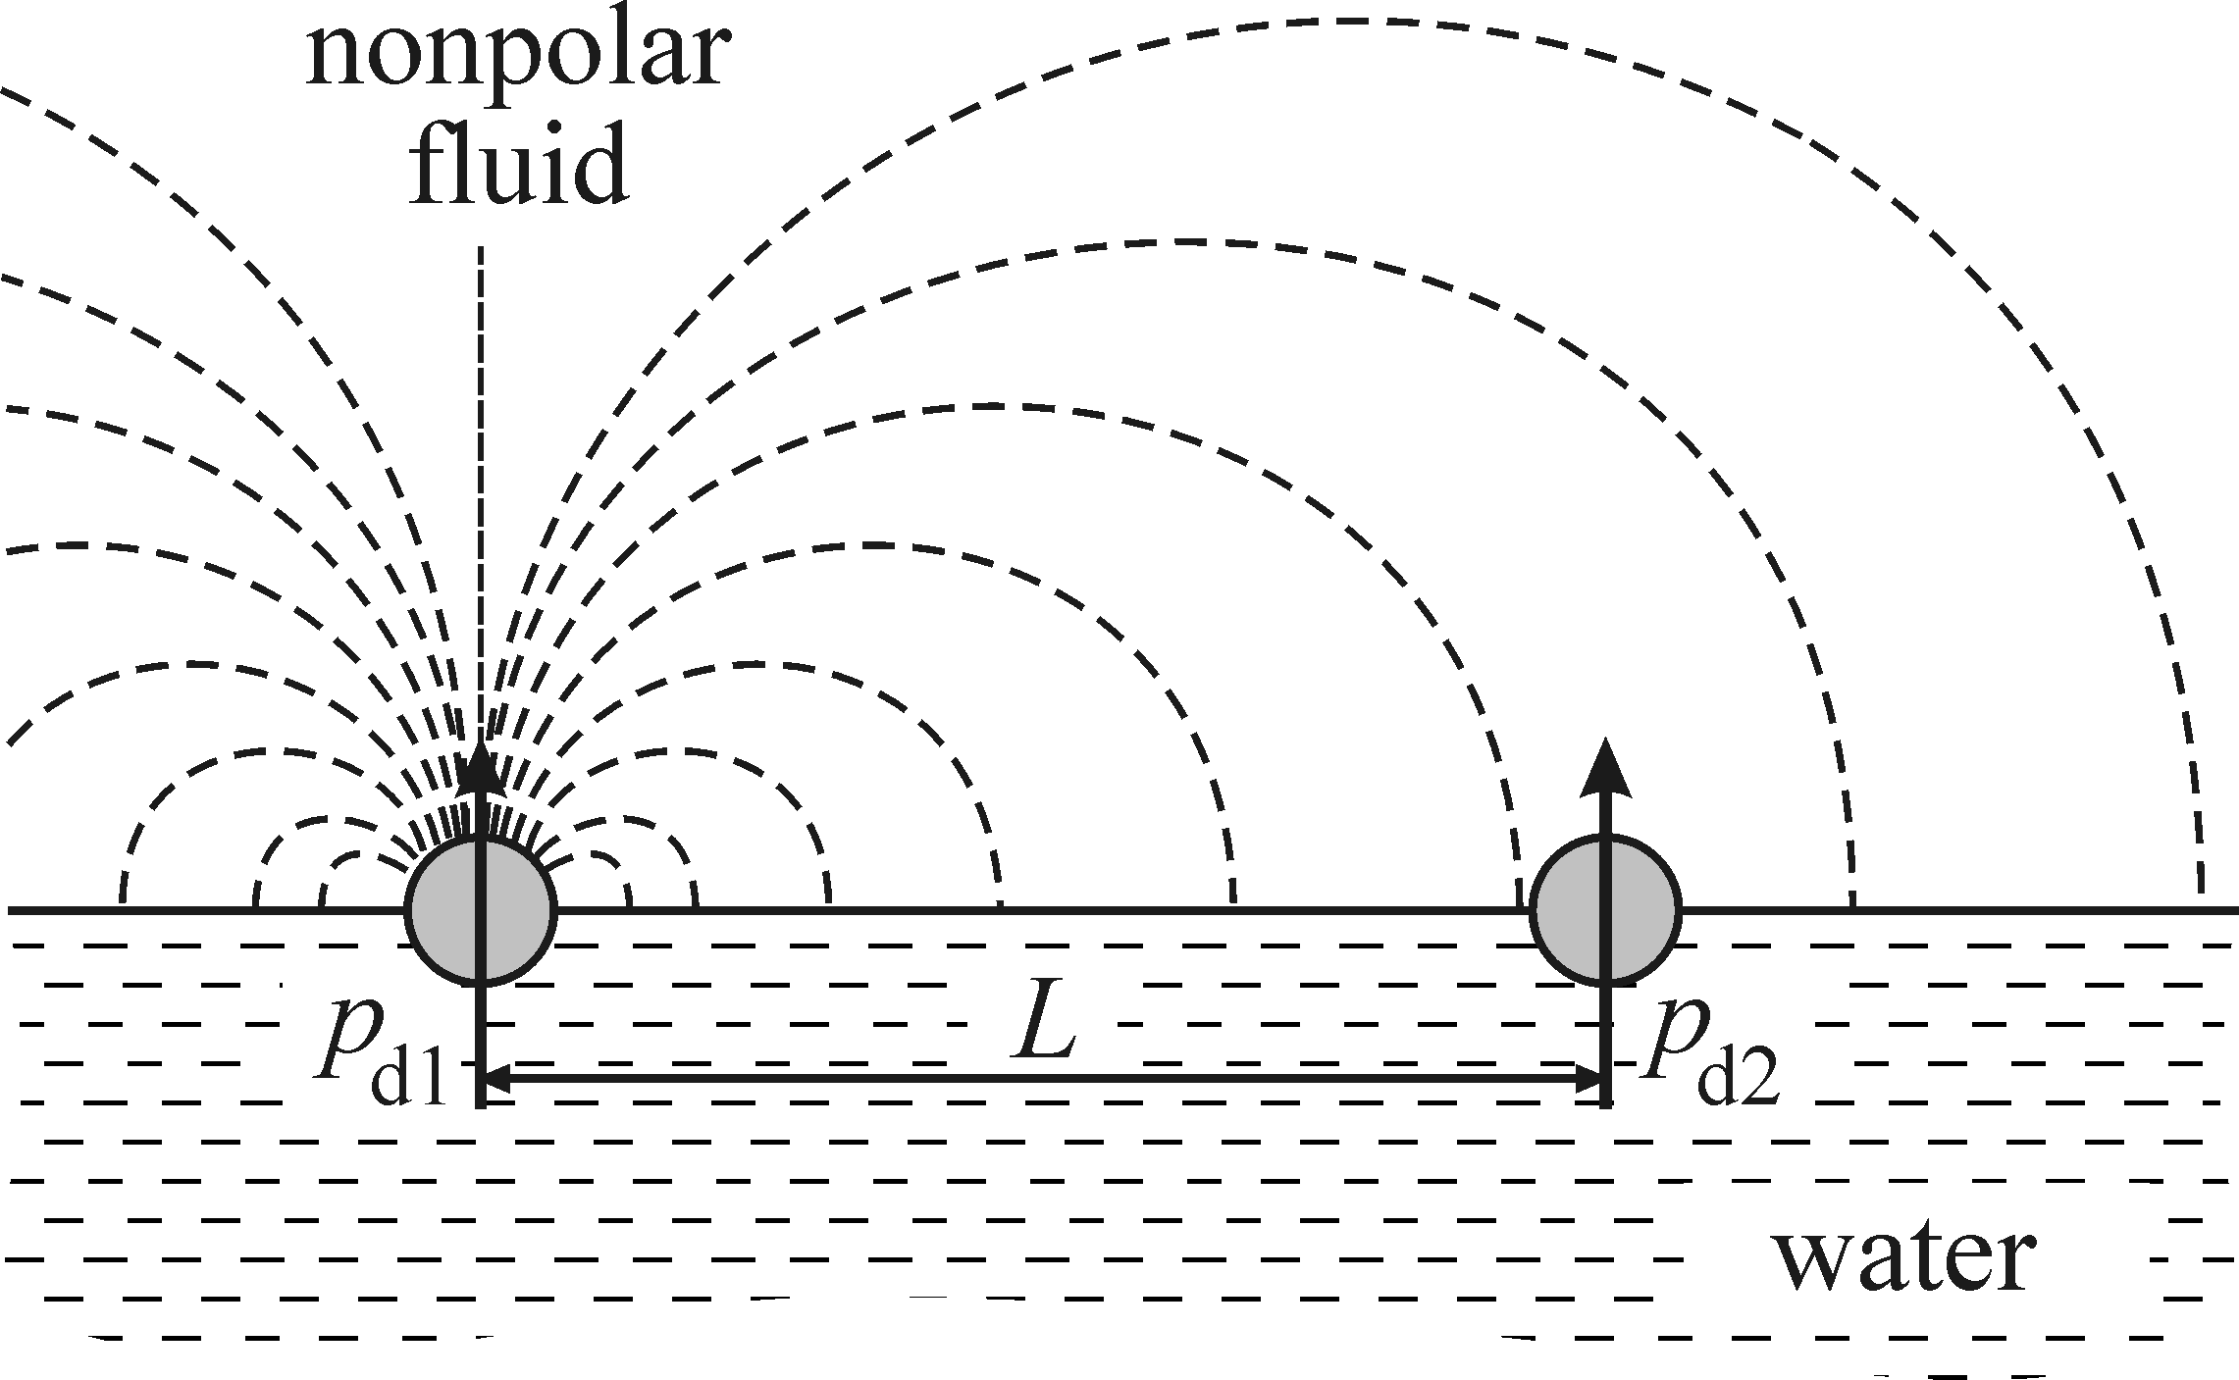
Fig. 6.2. Two particles attached to the boundary water–nonpolar fluid, which are separated at a center-to-center distance L. For L >> r_{c}, the electric field of each particle in isolation is identical to the electric field of a dipole.

Fig. 6.3. Dependence of the force coefficient f_{R} on the contact α for various values of the dielectric-constant ratio, ε_{pn}, denoted in the figure.
In addition, the derived equations enabled us to obtain analytical expressions for the asymptotic behavior of the electric field near the particle and far from it. The long-range asymptotics indicates that two similar particles repel each other as dipoles (Figure 6.2), whose dipole moments are expressed through the particle radius, contact angle, dielectric constant, and surface charge density. On the other hand, the analytical expression for the short-range asymptotics is important, because the electric field has an integrable divergence at the particle contact line. The knowledge of the short-range asymptotics ensures accurate calculation of the electrodipping-force coefficient, f_{R}(α,ε_{pn}).
For a fast and convenient application of the results obtained in the present paper, the reader could use the dependency f_{R}(α,ε_{pn}), as well as other dependencies, tabulated in the Appendix; see also Figure 6.3. After a theoretical upgrade, the results could be also applied for prediction of the electric-field-induced capillary attraction. (See Annex 6 for details.)

2.7. Shape of the capillary meniscus around an electrically charged particle at a fluid interface: Comparison of theory and experiment
Research Problem: Theory and experiment on particles at interfaces in relation to the fabrication of core-shell particles and colloidosomes
Partner group: Sofia (See Annex 7 for details)
Abstract: Here we consider the problem about the calculation of the shape of the fluid interface, ζ(r), around a charged particle at an emulsion interface (Figure 7.1). The interfacial deformation is influenced by the electric field created by charges at the boundary particle/oil. Our present data, and a number of recent experimental studies, prove the existence of such charges and establish that they lead to strong forces between the adsorbed particles due to the fact that the electric field is not screened in the nonpolar fluid (no electrolyte; Debye screening is absent). We digitized the coordinates of points from the meniscus profile around silanized glass particles attached to the interface water-tetradecane. The experimental shape of the oil-water interface is independent of the concentration of NaCl in the aqueous phase, which confirms that the electric field in the non-aqueous phases dominates the electrostatic interactions in the investigated system. The theoretical meniscus profile, ζ(r), can be computed in three different ways, which give numerically coincident results.
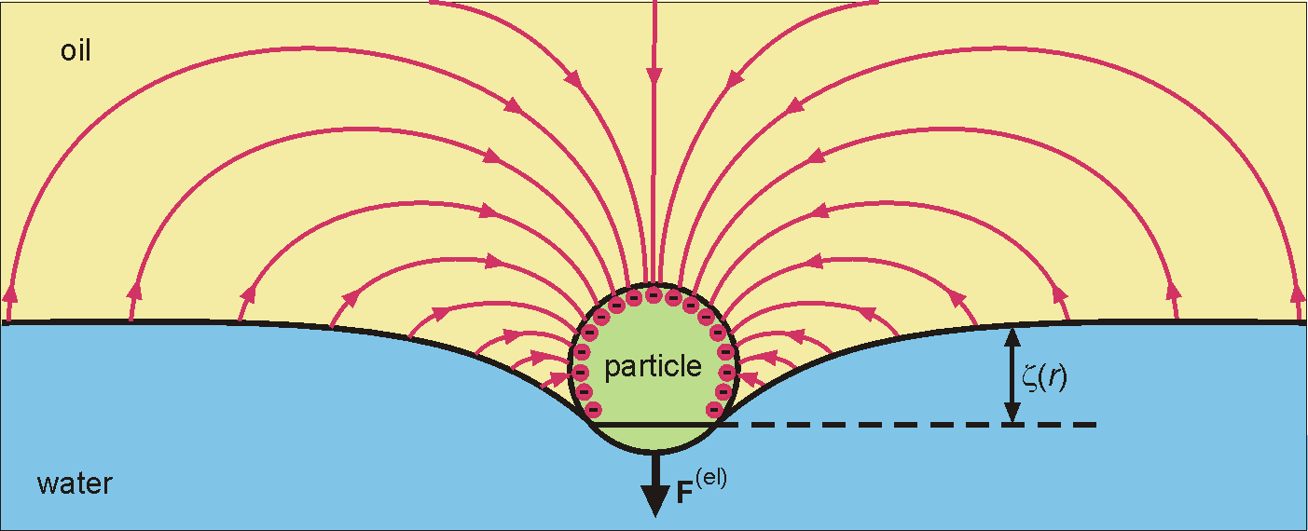
Fig. 7.1. Sketch of a charged particle at an emulsion interface. The interfacial deformation, ζ(r), is influenced by the electric field created by charges at the boundary particle/oil.

Further, it is proven that for sufficiently small particles the meniscus profile can be expressed as a superposition of pure electric and gravitational deformations, ζ(r) = ζ^{(el)}(r) + ζ^{(g)}(r). The latter fact considerably simplifies the calculations. The comparison of the gravitational and electric deformations indicates that the range of the electric deformation markedly depends on the contact angle: thus, for angles 50° and 150° the range is, respectively, about 1.5 and 5 contact-line radii. Special attention is paid to the comparison of theory and experiment. Based on the obtained theoretical expressions and numerical results, a relatively simple procedure for processing experimental data is developed, which is reduced to fitting the data for the meniscus profile by cubic parabola or linear regression. Next, the meniscus slope at the contact line is accurately determined by differentiation of the theoretical profile. This allows one to obtain values of the contact angle and surface charge density, which are more accurate than those determined by the goniometric method. For all investigated particles, excellent agreement between theory and experiment is achieved.
The theoretical analysis and the experimental results (Figures 7.2) lead to the conclusion that the electric-field-induced deformation of the fluid interface has a medium range, from 1.5 to 5 contact-line radii, depending on the contact angle. At larger distances, the meniscus profile is governed solely by the gravitational force. On the other hand, at closer distances the electric field creates a concavity (dimple) of significant depth in the fluid interface around the particle (Figure 7.2). The electric field produces a deformation (and capillary force) of medium range: it is neither long ranged as the gravity-induced capillary force, nor short ranged as the van der Waals attraction. For the investigated particles, the electric interfacial deformation has shorter range but greater amplitude than the gravitational deformation. The overlap of the electric-field-induced concavities around two particles can give rise to a powerful lateral capillary attraction and particle aggregation, as observed in the experiment. The results could be important for a better understanding of the lateral capillary forces between particles at emulsion interfaces, which lead to packing of the particle adsorption layer and stabilization of Pickering emulsions. (See Annex 7 for details)

Fig. 7.2. Meniscus shape, z(r), around a silanized glass particle at the interface water-tetradecane. R and r_{c} are the particle and contact-line radii; θ⁽¹⁾ is the goniometrically measured contact angle. The symbols are digitized points on the meniscus profile taken from photographs of the same particle at various NaCl concentrations. The solid line is the theoretical profile. The dash-dotted line is the gravitational profile, which shows the hypothetic shape of the meniscus if electrostatic effects are missing. The dashed line is the level of the horizontal non-disturbed oil-water interface far from the particle. The difference between the theoretical and gravitational profiles represents the electric deformation of the fluid interface, ζ^{(el)}(r).

2.8. Hydrodynamic theory of drop detachment from micro-pores with application to membrane emulsification
Research Problem: Theoretical analysis of membrane emulsification
Partner group: Sofia (see Annex 8 for details)

dispersed
liquid
continuous
liquid
flow
pressure
membrane

Fig. 8.1. Scheme of a typical membrane emulsification modulus. One of the liquid phases is pushed through the pores of a glass or ceramic membrane by the applied pressure difference. Small monodisperse drops are released at the membrane pores in the other liquid.

We investigate theoretically the production of monodisperse emulsions with the help of microporous membranes (Figure 8.1). To understand the mechanism of drop detachment from a pore, theoretical calculations for the case without cross flow have been performed. The Navier-Stokes equation has been solved and the fields of velocity and pressure have been computed for the interior and exterior of oil drop, which is growing at the orifice of a pore (Fig. 8.2). The driving force of the drop detachment turns out to be the viscous stress due to the flow of the liquid, supplied by the pore, which feeds the growing drop. This viscous stress does not cause a violation of the force balance in the system. Instead, the viscous stress produces a deformation of the drop, which leads to the appearance of a “necking” instability, in analogy with the case of a pendant drop. This instability brings about the drop detachment, which corresponds to a transition from stable to unstable equilibrium. The theoretical dependence of the drop radius on the applied driving pressure difference is obtained for two different regimes: (i) fixed flow rate and (ii) fixed pressure difference. For the latter regime, the theory predicts that the ratio of the drop and pore diameters must be about 3, as experimentally established in many studies.
Fig. 8.2. Calculated v_{z}-velocity component for a drop growing at the orifice of a circular pore; x₁ = 0 corresponds to the axis of rotational symmetry; x₂ = 0 corresponds to the plane of the orifice. The region on the left corresponds to Poiseuille flow inside the pore channel.

μ

3. Publications and Presentations
3.1. Publications. As mentioned above, a part of the results produced during the first and second year of our CONEX Project have led, or will lead, to publication of scientific papers. Their present status is either appeared; submitted or in preparation.
FIRST PROJECT YEAR
- A. Słowicka, Z.A. Walenta, “Conditions for creating thin liquid layers at the contact surface of two other liquids”, Mechanics of the 21st Century, Proceedings of the 21st ICTAM with CD-ROM, Eds. W. Gutkowski, T.A. Kowalewski, Springer Verlag 2005
- J. Blawzdziewicz, E. Wajnryb, “High-Frequency Linear Viscosity of Emulsions Composed of Two Viscoelastic Fluids”, Mechanics of the 21st Century, Proceedings of the 21st ICTAM with CD-ROM, Eds. W. Gutkowski, T.A. Kowalewski, Springer Verlag 2005
- P. A. Kralchevsky, K. D. Danov, V. L. Kolev, T. D. Gurkov, M. I. Temelska, and G. Brenn, “Detachment of oil drops from solid surfaces in surfactant solutions: Molecular mechanisms at a moving contact line”, Industrial & Engineering Chemistry Research 44 (2005) 1309–1321.
- K. D. Danov, P. A. Kralchevsky, B. N. Naydenov, and G. Brenn, “Interactions between particles with an undulated contact line at a fluid interface: Capillary multipoles of arbitrary order”, J. Colloid Interface Sci. 287 (2005) 121–134.
SECOND PROJECT YEAR
- H. Steiner, R. Treppner, G. Brenn, N. L. Vankova, S. Tcholakova, N. D. Denkov, “Numerical simulation and experimental study of emulsification in a narrow-gap homogenizer”, Chemical Engineering Science (2005) – submitted.
- K. D. Danov, P. A. Kralchevsky, “Electric Forces Induced by a charged colloid particle attached to the interface water–nonpolar fluid”, J. Colloid Interface Sci. (2005) – submitted.
- K. D. Danov, P. A. Kralchevsky, M. P. Boneva “Shape of the capillary meniscus around an electrically charged particle at a fluid interface: Comparison of theory and experiment”, Langmuir (2005) – submitted.
- K. D. Danov, P. A. Kralchevsky, N. C. Christov, et al., “Hydrodynamic theory of drop detachment from micro-pores with application to membrane emulsification”, J. Colloid Interface Sci. – manuscript in preparation.
- G. Brenn, T. Kowalewski, “Linear temporal stability analysis of a liquid filament in a laminar pipe flow of another immiscible liquid”, J. Fluid Mech. – manuscript in preparation.
- A. Słowicka, Z.A. Walenta, “Creating a thin liquid layer at the contact surface of two other liquids”, Abstract Book, Euromech Colloquium 472: “Microfluidics and Transfer”, Grenoble 2005.
- S. Błonski, T.A. Kowalewski, “Micro-flows investigations in production process of emulsions containing nanoparticles”, Abstract Book, Euromech Colloquium 472: “Microfluidics and Transfer”, Grenoble 2005.

In all these publications, the financial support of the CONEX Program has been thankfully acknowledged.
3.2. Reporting of the Project Results at Scientific Conferences and Symposia. The produced results have been reported at the following scientific conferences, congresses or symposia:
FIRST PROJECT YEAR
- S. Tcholakova, N. D. Denkov, I. B. Ivanov, Coalescence in β-lactoglobulin stabilized emulsions: experiment and interpretation", 15th International Symposium on Surfactants in Solution, Fortaleza, Brazil, 6-11 June, 2004. invited lecture.
- N. D. Denkov, S. Tcholakova, I. B. Ivanov, N. Vankova, T. Danner, Main factors controlling emulsification in turbulent flow, Conference on Physics and Design of Foams, Unilever R&D, Edgewater, New Jersey, July 22-23, 2004 (poster).
- A. Słowicka, Z. A. Walenta, Conditions for creating thin liquid layers at the contact surface of two other liquids, 21st International Congress of Theoretical and Applied Mechanics (ICTAM) August 15-21, 2004 (oral presentation).
- J. Blawzdziewicz, E. Wajnryb, High-frequency linear viscosity of emulsions composed of two viscoelastic fluids, 21st International Congress of Theoretical and Applied Mechanics (ICTAM) August 15-21, 2004 (oral presentation).
- S. Tcholakova, N. D. Denkov, I. B. Ivanov and T. Danner, Main factors controlling the emulsification process under turbulent conditions. Experiment and data interpretation, 21st International Congress of Theoretical and Applied Mechanics (ICTAM) August 15-21, 2004 (poster).
SECOND PROJECT YEAR
- P. A. Kralchevsky, K. D. Danov, N. C. Christov, M. P. Boneva, Particles at fluid interfaces: Electrodipping force, bending moments and particle-stabilized emulsions, Eleventh International Conference on Organized Molecular Films (LB11), Sapporo, Hokkaido, Japan, June 26-30, 2005 – invited lecture.
- P. A. Kralchevsky, K. D. Danov, V. L. Kolev, T. D. Gurkov, G. Brenn, Detachment of oil drops from solid surfaces in surfactant solutions: Molecular mechanisms at a moving contact line, Eleventh International Conference on Organized Molecular Films (LB11), Sapporo, Hokkaido, Japan, June 26-30, 2005 – poster.
- A. Slowicka, Z. Walenta, Creating a thin liquid layer at the contact surface of two other liquids, Euromech colloquium n°472: “Microfluidics and Transfer”, September 6-8, 2005, Grenoble, France.
- S. Błonski, T.A. Kowalewski, Micro-flows investigations in production process of emulsions containing nanoparticles, Euromech colloquium n°472: “Microfluidics and Transfer”, September 6-8, 2005, Grenoble, France.

4. Project Management
4.1. Organization of the Cooperation. The period between October 20, 2004 and October 20, 2005 was the second year of our project. In our work, we followed the planning and distribution of the tasks among the 3 partner groups, as formulated in the Proposal. The organization of the work was additionally specified during the Midterm Meeting, which took place at Warsaw between Thursday, October 28 and Saturday, October 30, 2004. Regular contacts between the partners were realized mostly through exchanges of e-mails, printed materials and experimental results. Prof. Dr. Krassimir Danov from Sofia spent a 7-day research period in the Technological University of Graz, from 4 to 10 December 2004. During the second project year, the basic directions of our activities have been:
- Experimental measurements to understand the mechanism of emulsification by narrow-gap homogenizer and the jet break-up method;
- Theoretical and computer modeling of the investigated processes and phenomena, including membrane emulsification, and test of the models against experimental data;
- Exchange of preliminary results between the 3 academic groups;
- Overview of the obtained results and preparation of publications.
4.2. The Midterm CONEX Meeting took place at the Institute of Fundamental Technological Research, Polish Academy of Sciences, Warsaw, between Thursday, October 28 and Saturday, October 30, 2004. The following representatives of the partner groups participated:
- IFDHT, Graz University of Technology (Austria): Prof. Dr. Günter Brenn (Coordinator), and Dr. Helfried Steiner;
- DMPF, Polish Academy of Sciences, Warsaw (Poland): Prof. Dr. Tomasz Kowalewski; Agnieszka Slowicka, Zbigniew Walenta; Slawomir Blonski; Maria Ekiel-Jezewska, and the other members of the team in Warsaw.
- LCPE, University of Sofia (Bulgaria): Assoc. Prof. Nikolai D. Denkov.
Below we present the Schedule of the Midterm Meeting. First we started with presentations about the work and the obtained results by the separate groups. In fact, this was a small scientific symposium with 8 presentations. There was a discussion after each talk, focusing not only on scientific details, but also on their applicability. Next, we continued the Organizational Meeting with discussions between separate groups of partners about specific tasks of the research cooperation.

Schedule of the Midterm Meeting in Warsaw, October 28 – 30, 2004

Thursday, 28 October 2004
TIME | ACTIVITY
19:45 | Get Together: Hotel Europejski Lobby

Friday, 29 November 2004
9:00 – 10:00 | S. Tcholakova, N. Vankova, N. D. Denkov, I. B. Ivanov, V. Valchev (Uni Sofia)  Drop breakup in turbulent flow: experiments and data interpretation
10:00 – 10:30 | Agnieszka Slowicka, Zbigniew Walenta (IPPT PAN)  Conditions for creating thin liquid layers at the contact surface of two other liquids
10:30 – 11:00 | Slawomir Blonski, Tomasz Kowalewski (IPPT PAN)  Experimental investigations and numerical modelling of the flow through the emulsifier
11:00 – 11:15 | Coffee Break
11:15 – 12:00 | H. Steiner, R. Teppner, G. Brenn (TU Graz)  Numerical simulation of the flow through a narrow-gap emulsifier and prediction of drop sizes in the resultant emulsions
12:00 – 12:45 | G. Brenn, H. Steiner (TU Graz)  Stability of liquid jets immersed in another liquid
13:00 – 14:30 | Lunch (Novi Swiat Café & Restaurant)
14.45 – 15:15 | Maria Ekiel-Jezewska (IPPT PAN)  Hydrodynamic interactions between particles on a flat free-surface
15:15 – 16:00 | K.D. Danov, P.A. Kralchevsky, B.N. Naydenov, G. Brenn (Uni Sofia & TU Graz), Interactions between Particles with an Undulated Contact Line at a Fluid Interface: Capillary Multipoles of Arbitrary Order
16:00 – 16:15 | Coffee Break
16:15 – 16:45 | P. A. Kralchevsky, K. D. Danov, V.L. Kolev, T. D. Gurkov, M. I. Temelska, G. Brenn (Uni Sofia & TU Graz)  Detachment of Oil Drops from Solid Surfaces in Surfactant Solutions: Molecular Mechanisms at a Moving Contact Line
16:45 – 17:45 | General discussion concerning CONEX second year planning
19:30→ | Concert in the Warsaw Philharmonics by K. Penderecki Symphony Varsovia, Lacrimosa (Polskie Requiem), Ludwig van Beethoven

Saturday, 30 October 2004
10:30 – 12.00 | CONEX, reporting, planning
12:00 – 12:30 | Laboratory tour
12:30 – 14.00 | Lunch
14:00 | End of the meeting

Schedule of the Final Meeting in Graz, October 28 – 30, 2005

Friday, 28 October 2005
TIME | ACTIVITY
15:00 | Get Together at the Institute
15:15-17:30 | Visit of the laboratories of the institute (W. Meile, B. Breitschädel, C. Pilz)

Saturday, 29 November 2005
9:00 – 9:40 | Peter A. Kralchevsky (Uni Sofia)  Particle-stabilized emulsions: Interaction between electrically-charged particles at oil-water interfaces
9:40 - 10:20 | Peter A. Kralchevsky (Uni Sofia)  Hydrodynamic theory of drop detachment from micro-pores with application to membrane emulsification
10:20-10:40 | Tomasz Kowalewski (IPPT PAN)  Modelling emulsion by molecular dynamics
10:40-11:00 | Coffee Break
11:00-11:30 | Nikolai Denkov (Uni Sofia)  Experimental study of oil emulsification in narrow-gap homogenizers - effects of driving pressure, oil viscosity, and interfacial tension on the drop size
11:30-12:00 | Helfried Steiner (TU Graz)  Numerical simulation of emulsification in a cylindrical narrow-gap homogenizer
12:00-12:50 | Tomasz Kowalewski (IPPT PAN)  Experimental and numerical study of the shear flow in planar channel emulsifier
12:50-14:20 | Lunch Break
14:20-14:40 | Tomasz Kowalewski (IPPT PAN)  Liquid jet in co-flow, experimental study
14:40-15:30 | Günter Brenn (TU Graz)  Theoretical study on the instability of a viscous liquid jet in a viscous co-flow for emulsification
15:30-16:00 | Discussion and outlook on further cooperation in the future
16:00 | - End of the CONEX final meeting -
17:00 | Get-together for dinner
19:00-22:45 | Visit to the Opera Graz: Hoffmanns Erzählungen (J. Offenbach)

Sunday, 30 October 2005
18:20 | Departure of the Bulgarian colleagues from Graz airport

According to our plan, the Final Project Meeting will took place in Graz, October 28–30, 2005. The Schedule of this meeting is given in the previous page. The results from the second year have been reported and discussed. The preparation of joint publications, resulting from the project, as well as possibilities for extension of the cooperation, have been also discussed.

4.3. Mobility. During the second project year, six short visits and one 7-day research period (Prof. K.D. Danov from Sofia in TU Graz) were realized, as follows:
Prof. Günter Brenn (Graz), three days in Warsaw (28 – 30.10.2004);
Dr. Helfried Steiner (Graz), three days in Warsaw (28 – 30.10.2004);
Assoc. Prof. Nikolai Denkov (Sofia), three days in Warsaw (28 – 30.10.2004);
Prof. Krassimir Danov (Sofia), 7 days in Graz (4 – 10.12.2004);
Prof. Tomasz Kowalewski (Warsaw), three days in Graz (28 – 30.10.2005);
Prof. Peter Kralchevsky (Sofia), three days in Graz (28 – 30.10.2005);
Assoc. Prof. Nikolai Denkov (Sofia), three days in Graz (28 – 30.10.2005).
The six short (3-day) visits are related to the Midterm and Final Meetings in Warsaw and Graz.

4.4. Involvement of young scientists
In IFDHT, Graz, Austria – 1 young scientist (postdoc) was involved in the research on the project
LCPE, Sofia, Bulgaria – 4 young scientists took part in the research on the Project: the postdoc, Dr. Slavka Tcholakova, and the Ph.D. Candidates, Ms. Nina Vankova, Ms. Mariana Boneva, and Mr. Nikolai Christov,
IPPT PAN, Warsaw, Poland – 2 Ph.D. students

4.5. Involved scientifically qualified females
IFDHT, Graz, Austria - 1 scientifically qualified female (Ph.D. by date of project start)
In LCPE–Sofia, 9 qualified females participated in the work on the project. The names of Dr. Slavka Tcholakova, Ms. Nina Vankova and Ms. Mariana Boneva have been just mentioned. Other involved researchers and chemists are Ms. Elka Basheva; Ms. Stefka Kralchevska; Ms. Cenka Pishmanova; Ms. Dora Todorova, Ms. Mariana Paraskova, and Ms. Elena Kostova,
DMPF, Warsaw, Poland – 1 postdoc and 2 Ph.D. students

4.6. EU Proposals
The groups in Graz and Sofia applied jointly with other 15 teams from 13 European countries for a COST Project entitled: “Physics of Drops”.
(see details at http://www.ulg.ac.be/grasp/cost.html)

5. Conclusion
In summary, the results of the groups in Graz, Sofia and Warsaw produced during the second CONEX Project year, led to the presentation of 4 communications at conferences, and to the publication of 7 scientific papers (see section 3 above).
Total, for the whole two-year project, results produced by the three groups led to the presentation of 9 communications at conferences, and to the publication of 11 scientific papers (see section 3 above).
The experience accumulated during the work on the project, and the established close relations between the three teams will facilitate the future participation of these teams in other scientific projects. (One of them is the EU COST Project “Physics of Drops”.)

